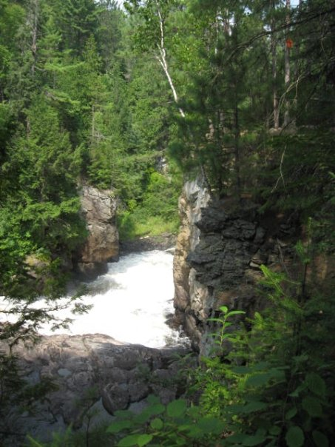



Township of Johnson Zoning By-law 91-219 Consolidation as approved January 18, 2012

**[](http://www.papineau-cameron.info/home/History.htm)**

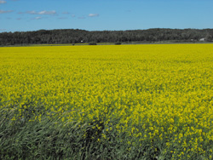

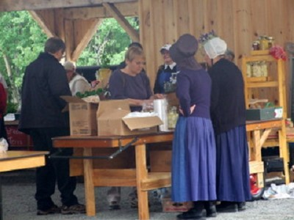





**TOWNSHIP OF JOHNSON**

**ZONING BY-LAW**

Table of Contents

Foreword 2

Consolidation 2

Section 1 ADMINISTRATION 3

Section 2 CONFORMITY REQUIREMENTS 7

Section 3 DEFINITIONS 8

Section 4 GENERAL PROVISIONS 51

4.1 Accessory Buildings, Structures and Uses 51

4.2 Auto Service Station, Gasoline Bar, Car Washing 54

4.3 Buildings to be Moved 55

4.4 Camp 55

4.5 Change of Use 55

4.6 Cumulative Standards 56

4.7 Established Building Line in Built-up Area 56

4.8 Day Nurseries 56

4.9 Exception Zone 56

4.10 Farm Use 56

4.11 Flood Plain 57

4.12 Frontage on a Public Street or Private Road 58

4.13 Group Homes 59

4.14 Helipad, Heliport 59

4.15 Illumination 59

4.16 Kennel 60

4.17 Land Suitability for Use and Organic Soils 60

4.18 Licenses, Permits and Other By-laws 60

4.19 Loading Space Requirements 60

4.20 Mine Hazards 61

4.21 Minimum Distance Separation and Special Setbacks 62

4.22 Non-Conforming and Non-Complying Uses 64

4.23 Occupancy Restrictions 65

4.24 Outside Storage, Sales and Display 66

4.25 Parking and Storage of Vehicles 66

4.27 Parts of Buildings/Structures Above Height Level 70

4.28 Permitted Projections 71

4.29 Prohibited Uses 72

4.30 Recreational Vehicles 72

4.31 Railway Crossing 73

4.32 Sight Triangles 73

4.33 Signs 74

4.34 Streets and Parks 74

4.36 Use by Public Authority or Public Utility 74

4.37 Water and Sewage Disposal Systems 75

4.38 Wind Turbine and Renewable Energy Undertaking 75

4.39 Yard Requirements when Waterways are Involved 75

4.40 Zones Applying to More than One Property 76

Section 5 ZONES 77

5.1 ZONE CLASSIFICATION 77

5.2 ZONES 77

5.3 INTERPRETATION OF ZONE BOUNDARIES 78

5.4 Residential Low Density – R1 79

5.5 Multiple Residential – MR 81

5.6 RURAL RESIDENTIAL – RR 83

5.7 SEASONAL RESIDENTIAL – SR 86

5.8 GENERAL COMMERCIAL – GC 88

5.9 HIGHWAY COMMERCIAL – HC 90

5.10 RECREATIONAL COMMERCIAL – RC 92

5.11 RESERVED 94

5.12 RURAL INDUSTRIAL – GM 95

5.13 MINERAL EXTRACTION - MX 97

5.14 WASTE DISPOSAL - MWD 99

5.15 RURAL – R 100

5.16 AGRICULTURAL – A-1 102

5.17 AGRICULTURAL – A-2 104

5.18 OPEN SPACE – OS 107

5.19 SHORE ENVIRONMENTAL PROTECTION AREA – SEP 109

APPENDIX 1 110

SCHEDULE A 112

* Disclaimer: Photographs, illustrations, diagrams and clip art are inserted to make the document more user-friendly but are not intended to be a legal component of the Zoning By-law.

**The Corporation of the Township of Johnson**

**Comprehensive Zoning By-law**

# Foreword

*This Zoning By-law affects all lands within the Township of Johnson. To use this By-law, locate the subject property on the map schedules provided and determine the zone(s) which affects the land. Then review the specific regulations relating to the zone(s) in* ***Section 5: Zones****. It is also important to review* ***Section 4: General Provisions*** *and any applicable definitions in* ***Section 3: Definitions****.*

*Changes to the requirements contained in this By-law may be made with prior approval by the Municipality as provided for under the Planning Act. Significant changes may be made through the zoning by-law amendment process. Minor variations may be granted by the Municipal Committee of Adjustment. Both processes require formal applications to be submitted to the Municipality and both involve mandatory public notification.*

# Consolidation

*The following by-law is a consolidation of By-law 91-219 as amended including By-law 2012-685 as approved by the Ontario Municipal Board. The effective date of By-law 2012-685 is January 18, 2012.*

|  |
| --- |
| Section 1 ADMINISTRATION |

***Explanatory Note***

*Section 1 identifies the administrative controls and requirements of the By-law. It names the By-law, states its relationship with other by-laws, defines the area to which it applies, how it is to be enforced, etc. In essence, it identifies the legal parameters within which the By-law functions.*

1.1 Title

## This By-law shall be known as the Zoning By-law or By-law No.91-219, as amended of the Corporation of the Township of Johnson.

1.2 Applications and Plans

In addition to the requirements of any Building By-law, every application for a building permit shall be accompanied by a plan, drawn to scale and showing the following:

1. The true dimensions and/or legal description of the lot to be built upon or otherwise used;
2. The proposed location, height and dimensions of any building, structure or use proposed for such lot;
3. The proposed location, height and dimensions of yards, landscaping, parking areas and loading spaces required by this By-law;
4. The location of all existing buildings or structures on the lot, including the lot area, lot coverage of existing and proposed structures; and
5. A statement, signed by the owner disclosing the exact use of all existing and proposed uses of land, buildings or structures and such other information as may be required to determine whether the uses conform with the requirements of this by-law.

1.3 Defined Area

The provisions of this By-law shall apply to all lands within the municipal boundaries of the Corporation of the Township of Johnson.

1.4 Enforcement

This By-law shall be administered by the Chief Building Official or such other person as may from time to time be designated by Council, and no permit for the use of land or for the erection or use of any building or structure or approval of application for any municipal license within the jurisdiction of the Council shall be issued or given where the proposed building, structure or use would be a violation of any provision of this By-law.

1.5 Inspection of Land, Buildings and Structures

1. Subject to Sections 49 and 49.1 of the *Planning Act*, 1990, the Chief Building Official or any other officer or any person acting under his or her instructions, and upon producing proper identification, is hereby authorized to enter, at all reasonable times, upon any property or premises for the purpose of carrying out his duties under this By-law.
2. Notwithstanding any provisions of **Section 1.5 (a)** hereof to the contrary, no officer or employee of the Corporation shall enter any room or place actually being used as a dwelling unit without obtaining the consent of the occupier, first having informed the occupier that the right of entry may be refused, except under the authority of a search warrant issued under Section 158 of the *Provincial Offenses Act*, 1990; and
3. No person shall obstruct or attempt to obstruct an officer or person acting under the officer’s instructions in the exercise of a power authorized under the *Planning Act*.

1.6 Penalty

* 1. Every person who violates any of the provisions of this By-law is guilty of an offense and upon conviction thereof shall forfeit and pay a penalty not exceeding Twenty-Five Thousand Dollars ($25,000.00), on a first conviction, add Ten Thousand Dollars ($10,000.00) on a subsequent conviction for each day or part thereof upon which the contravention has continued after the day of the first conviction;
  2. Where a corporation is convicted under subsection (a), the maximum penalty that may be imposed is Fifty Thousand Dollars ($50,000.00) on a first conviction and Twenty Five Thousand Dollars ($25,000.00) on a subsequent conviction for each day or part thereof upon which the contravention has continued after the day of the first conviction; and
  3. In the case where any building or structure is erected or altered, or any part thereof is used, or any lot is used, in contravention of any of the requirements of this By-law, such contravention may be restrained by action at the instance of any ratepayer or of the Corporation pursuant to the provisions of the Municipal Act or the Planning Act in that behalf.

1.7 Repeal and Relationship to Former By-laws

Insofar as it applies to the lands affected by this By-law, any By-laws passed under Section 34 of the Planning Act, 1990, or its predecessor, are hereby repealed.

The adoption of this By-law shall not prevent any pending or future prosecution of, or action to abate any existing violation of the said By-laws if the violation is also a violation of any of the provisions of this By-law.

1.8 Validity

Should any Section or part of a Section of this By-law or Schedule hereto be declared by a court of competent jurisdiction to be invalid, the same shall not affect the provisions of this By-law as a whole or any part thereof other than the part declared to be invalid.

1.9 Other By-laws, Licenses, Permits and Regulations

Nothing in this By-law shall exempt any person from complying with the requirements of any other By-law in force within the area affected by this By-law, or from applying for and obtaining any permit, license, permission, authority or approval required by this or any other By-law or regulation of the Corporation or by any other law in force from time to time.

1.10 Conflict

In the event of conflict between this By-law and amendments thereto, and any general or special By-law, the most restrictive By-law shall prevail.

1.11 Interpretation

1. **Definitions**

Definitions are given in this By-law to aid in the understanding and implementation of the true spirit, intent and meaning of the By-law. They are not to be used to avoid an obligation imposed by the By-law or any requirement enacted in a substantive provision of the By-law;

1. **Citation**

This By-law may be cited by its long title (“A By-law to Regulate the Use of Land, Buildings and Structures within the Township of Johnson”), its short title (“Township of Johnson Zoning By-law”) or its by-law number, and any such citation is to be taken as meaning the By-law as amended;

1. **Gender Neutrality**

This By-law is gender neutral and, accordingly, any reference to one gender includes the other;

1. **Plural and Singular**

In this By-law, words in the singular include the plural, and words in the plural include the singular;

1. **References**

Appendices, footnotes, glossaries, headings, indices, marginal notes and references to former enactments or enabling legislation after a section or other division of the By-law, do not form part of the By-law and are inserted for convenience of reference only; and

1. **Measurement Units**

This By-law utilizes the metric system to establish measurements when such measurements form part of a regulation or a requirement.

|  |
| --- |
| Section 2 CONFORMITY REQUIREMENTS |

***Explanatory Note***

*This short section establishes the authority and legitimacy of the By-law. It is composed of three statements which establish the primacy of the regulations stated within.*

2.1 No land, building or structure shall be used and no building or structure shall be erected or enlarged or placed for any purpose within the area defined by this By-law, except as specifically, or by necessary implication, authorized by this By-law and in conformity with all the applicable provisions of this By-law.

## 2.2 Subject to the granting of such minor variances as may be necessary, no lands shall be severed from any existing lot if the effect of such action is to cause the original, adjoining, remaining or new building, structure, lot or use of land to be in contravention of any provision of this By-law.

**2.3** Where a use does not take place within a building, but a regulation in this By-law imposes a requirement premised on the use being in a building, the requirement applies as though the actual area occupied by the use was in a building.

|  |
| --- |
| Section 3 DEFINITIONS |

***Explanatory Note***

*For the purpose of this By-law, the definitions and interpretations given in this Section shall govern. In this By-law, the word "shall" is mandatory and not directory; words in the singular include the plural, words in the plural include the singular; the word "used" includes "arranged", "designed" or "intended to be used". The word "occupied" shall include "designed to be occupied" and "arranged to be occupied".*

3.1 Abattoir

Means a building or structure where animals are killed for market but shall not include a rendering plant.

3.2 Accessory

When used to describe a use, building or structure, means a use, building or structure naturally or normally incidental, subordinate and exclusively devoted to a main use, building or structure and located on the same lot therewith.

**3.3 Adventure Game**

Means an outdoor sport or recreation operated commercially in which participants attempt to capture a flag or some other object and return it to their home base, and may carry one or more of the following equipment: paint pellet pistols with a CO2 cartridge, paint pellets, safety goggles to prevent pellets from striking participants' eyes, and armbands to identify team participants.

**3.4 Aggregate**

Means gravel, sand, clay, earth, shale, limestone, dolostone, sandstone, marble, granite, rock other than metallic ores, asbestos, graphite, kyanite, mica, nepheline syenite, salt, talc, wollastonite, mine tailings or other material prescribed under the Mining Act.

3.5 Agricultural Use

Shall mean the use of land, building(s) or structure(s) for:

**(a)** The growing of crops, including all related activities such as soil preparation, manure or fertilizer storage and application, planting, spraying, grain drying, irrigating, harvesting and also including the storage and sale of the crops;

**(b)** Animal husbandry including the raising, boarding, and keeping of all forms of livestock and fish, and all related activities such as breeding, training, feeding, manure storage and grazing;

1. The production of animal products such as milk, eggs, wool, fur, or honey, including related activities such as the collection, storage and sale of the products;
2. Maple syrup production; and
3. The use and storage of all forms of equipment or machinery needed to accomplish the foregoing activities.

Agricultural use shall not be construed to include commercial activities related to agriculture such as abattoirs, tanneries and retail sales outlets, or manufacturing and processing activities involving farm crops or animal products such as cheese factories, grain mills or retail seed sales.

3.6 Airfield

Means any land, lot or buildings used for the purpose of landing, storing, taxiing or taking off of private or commercial aircraft pursuant to the regulations of the appropriate authority.

3.7 Alter

**(a)** When used in reference to a building, structure or part thereof, means:

**i)** To change any one or more of the external dimensions of such building or structure; or

**ii)** To change the type of construction of the exterior walls or roof of such building or structures; or

**iii)** To change the use of such building or structure or the number or types of uses or dwelling units contained therein.

**(b)** When used in reference to a lot means:

To change the boundary of such lot with respect to a street or lane; or

To change any dimension or area, relating to such lot; or

To change the use of such lot or the number of uses located thereon.

**(c)** When used in reference to a shoreline

**i)** Means to change, straighten, divert or interfere in any way with the channel of any watercourse.

3.8 Ambulance Facility

Means a building or part of a building where professional paramedics are stationed and their vehicles and equipment are kept.

3.9 Antique Store

Means a retail store selling any old and authentic objects of personal property which were made, fabricated or manufactured sixty or more years earlier and which have a unique appeal and enhanced value mainly because of its age, and, in addition, may include the sale of any article of personal property which was made, fabricated or manufactured twenty or more years earlier and because of public demand had attained a value in a recognized commercial market which is in excess of its original value.

3.10 Attached

Means a building or structure otherwise complete in itself which is connected to, and which depends for structural support upon a division wall or walls shared in common with an adjacent building or buildings.

3.11 Auto Body Shop

Means a building with a service bay, where painting, refinishing, restoration or repairs to the coach works of motor vehicles are performed for gain or profit.

3.12 Auto Repair Garage

Means a building used for the storage repair and servicing of motor vehicles, having at least one (1) service bay where repairs essential to the actual operation of a motor vehicle are performed.

3.13 Auto Service Station

Means a place for supplying fuel, oil and minor accessories for motor vehicles at retail, direct to the consumer and having at least one (1) service bay where repairs to the actual operation of motor vehicles may be performed and includes a card-lock facility. If more than two (2) motor vehicles are kept on the premises for the purpose of selling such vehicles, then such establishment shall also be classified as an automotive sales establishment.

3.14 Automotive Sales Establishment

Means a building and/or lot used principally for the display and sale of new and/or used motor vehicles and may include the servicing, repair, cleaning, body repair and repainting of motor vehicles, the sale of automotive accessories and related products and the leasing or renting of motor vehicles, but shall not include any other defined automotive uses.

3.15 Basement

Means any storey below the first storey which is at least 50% above finished grade measured from floor to finished ceiling.

(See illustration).

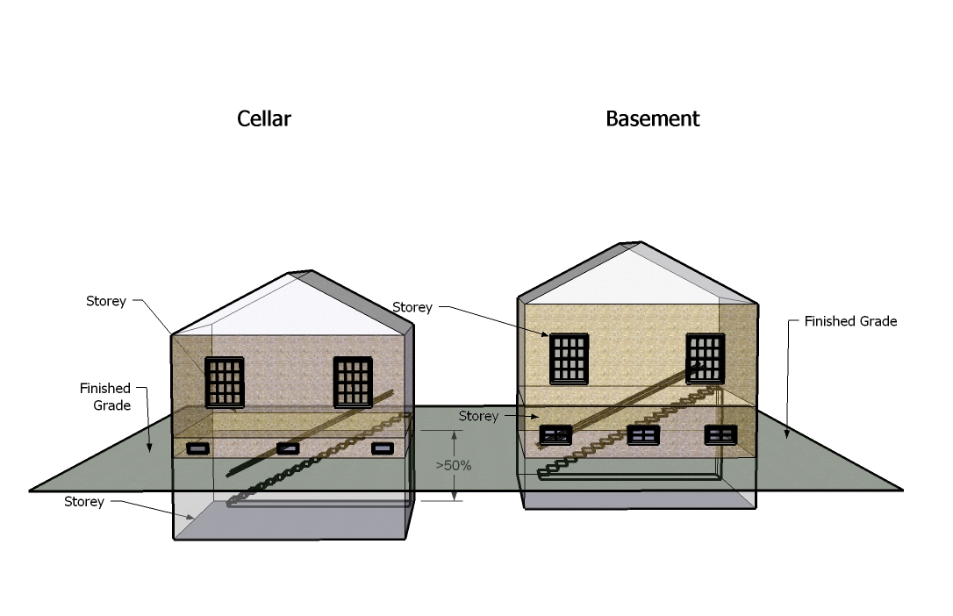

3.16 Batch Plant, Asphalt or Concrete

Means an industrial facility used for the production of asphalt or concrete products, used in building or construction and includes facilities for the administration or management of the business, the stockpiling of bulk materials used in the production process of finished products manufactured on the premises and the storage and maintenance of required equipment.

3.17 Bed and Breakfast Establishment

Means a private dwelling designed to be used in part for the accommodation of the travelling or vacationing public, containing therein four (4) or fewer suites or guest rooms.

**3.18 Boat House**

Means a building or structure or part thereof not over 4.8 m [15.7 ft.] in height, used for the storage of private boats and equipment accessory to their use, as an accessory use to a residential use, no part of which shall be used for any habitable room. Despite anything in the foregoing to the contrary, rooftop decks or patios and screened enclosures shall be permitted provided that the total aggregate height of any boat house does not exceed the maximum height limit by more than 1.2 m [4 ft.].

3.19 Building

Means any structure used or intended for sheltering any use or occupancy. The word "building" shall include the whole of such structure or part thereof.

3.20 Building Height

Means the vertical distance between the average finished grade at the base of the building and in the case of a flat roof, the highest point of the roof surface or parapet wall, whichever is the highest, or in the case of all other types of roofs, the mean height level between the base of the roof and highest point of the roof (see illustrations).

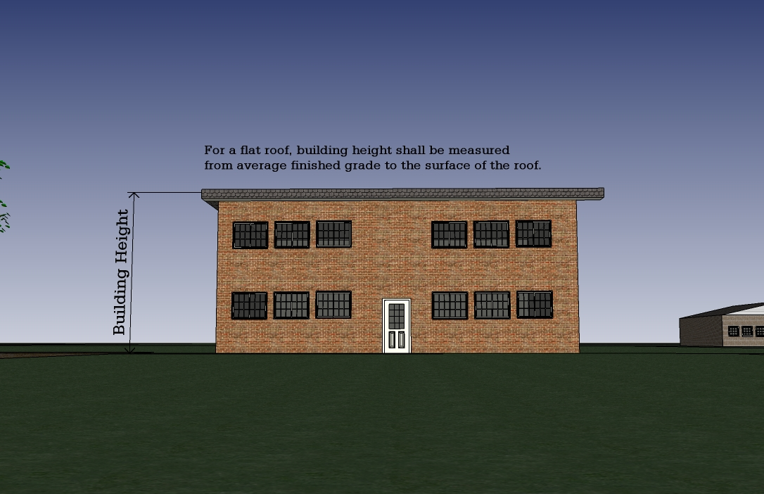**Illustration of Building Height**

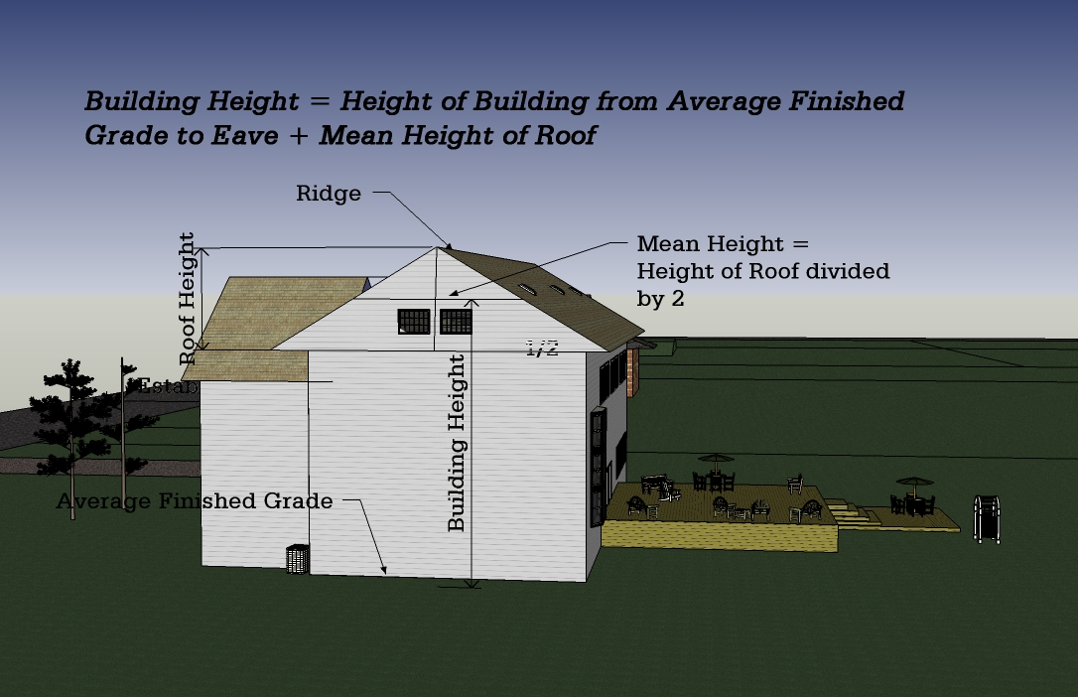

3.21 Building, Main

Means a building in which is conducted the principle uses of the lot on which it is situated (see illustration).

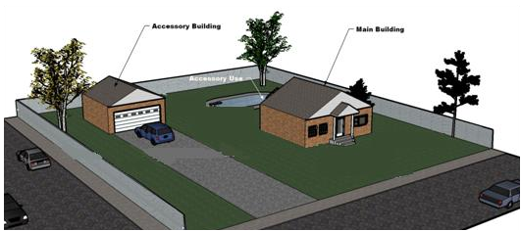

3.22 Building Supply Store

Means a building where building supplies such as lumber, millwork, siding, roofing, plumbing, electrical, heating, air conditioning, home improvement and similar goods are stored, displayed, or kept for retail sale. This definition shall not include a lumber yard nor a salvage yard.

3.23 Camp (Hunt Camp, Fishing Camp)

Means a building or structure other than a recreational vehicle as defined which is intended to provide basic shelter and accommodation on a temporary basis (i.e., weekend, vacation) for persons engaged in such activities as hunting, fishing, snowmobiling, hiking or other similar forms of recreation.

3.24 Campground

Means an area of land, managed as a unit, providing short term accommodation for tents, tent trailers, recreational vehicles or campers and may include accessory uses such as a Laundromat, convenience store, sale of propane fuels and recreational uses for persons using the campground where a fee is charged or paid for such accommodation.

3.25 Car Port

Means a structure open on at least two sides and intended to be used for the sheltering of one or more motor vehicles.

3.26 Car Washing Establishment

Means a building or portion thereof used for washing or cleaning of motor vehicles for gain, and may include the sale of gas and oil to its customers.

**3.27 Catering Establishment**

Means a commercial establishment in which food and beverages are prepared for consumption off the premises and are not served to customers on the premises or to take out.

**3.28 Cellar**

Means any storey below the first storey which is more than 50% below finished grade (measured from finished floor to finished ceiling) (see illustration).

3.29 Cemetery

Means a cemetery within the meaning and as regulated by the *Cemeteries Act*.

3.30 Chief Building Official

Means an officer or employee of the Corporation of the Township of Johnson charged with the duty of enforcing the provisions of the *Building Code Act*.

3.31 Clinic

Means a building used solely for the purpose of consultations, diagnosis and treatment of patients, by two (2) or more legally qualified physicians, dentists, optometrists, chiropodists, chiropractors or drugless practitioners, together with their qualified assistants and without limiting the generality of the foregoing, the building may include administrative offices, waiting rooms, laboratories, pharmacies or dispensaries directly associated with the clinic, but shall not include accommodation for in-patient care or operating rooms for major surgery.

3.32 Commercial Greenhouse

Means a building used for the growing of flowers, vegetables, shrubs, trees, and similar vegetation for wholesale or retail sale. This definition shall not include any premises for the growing of mushrooms.

**3.33 Commercial Vehicle**

Means a motor vehicle having permanently attached thereto a truck or delivery body and includes ambulances, hearses, fire apparatus, police patrols, motor buses and tractors used for hauling purposes on the highway.

**3.34 Communications Facility**

Means an installation which transmits, receives, and/or relays communications such as a microwave relay tower, significant antenna, significant antenna, telephone or telegraph line, cellular telephone tower, radio or television broadcast tower or similar facility.

3.35 Community Centre

Means any parcel of land or building(s) used for community activities whether used for commercial purposes or not, and the control of which is vested in the municipality, a local board or agent thereof.

3.36 Conservation Use

Means the use of lands which are intended to remain open in character with the priority use given to preservation of their ecological uniqueness, wildlife production and their natural features and may include non-commercial recreational uses only if conservation of the resource is not jeopardized.

3.37 Construction Yard or Contractor's Yard

Means the yard of a building contractor or company used as a depot for the storage and maintenance of equipment used by the contractor or company, and may include facilities for the administration or management of the business and the stockpiling or storage of supplies used in the business, but does not include the crushing of virgin or recyclable aggregates or materials and the wholesale or retail sale of building supplies or home improvement supplies.

**3.38 Continuum-of-Care Facility**

Means a facility which may include a senior citizens apartment building, a nursing home, a long-term care facility, home for the aged and facilities associated with, and designed specifically to serve, the senior citizens apartment building, nursing home, long-term care facility, home for the aged, such as hospitals, clinics, recreation centres, cafeterias and personal service establishments and may also include independent senior's accommodation in separate structures/living units that share in services, such as  meals, medical care services, or recreation that are provided by the facility.

3.39 Convenience Store

Means a building or part of a building used primarily for the sale of grocery and confectionary items and incidentally for the sale of such other merchandise as is required to fulfil the day-to-day needs of the surrounding community.

3.40 Corporation

Means the Corporation of the Township of Johnson.

3.41 Council

Means the Council of the Corporation of the Township of Johnson.

**3.42 Crisis Care Facility**

Means a building or part of a building which is used to provide for the supervised residency of persons requiring immediate emergency shelter and aid for a short to interim period of time and without limiting the generality of the foregoing, includes a facility for battered or abused adults and/or children or elderly persons.

3.43 Day Nursery - Licensed

Means a place wherein the temporary care of children is provided in facilities and by staff licensed by the Province of Ontario and operated in accordance with the provisions of the *Day Nurseries' Act*.

3.44 Day Nursery - Private Home

Means a place wherein the temporary care of children is provided, which is operated as an accessory use within a residential dwelling unit and is not required to be licensed by the Province but shall comply with the applicable provisions of the Day Nurseries' Act.

3.45 Deck

Means a structure abutting a dwelling or building with no roof or walls except for visual partitions and railings which is constructed on piers or a foundation above-grade for use as an outdoor living area.

3.46 Detached

When used in reference to a building, means a building which is not dependent on any other building for structural support or enclosure.

3.47 Dock

Means an accessory structure used for the mooring of marine vessels which is designed to float freely on the surface of the water body and which may be secured to the shoreline.

**3.48 Driveway**

Means a vehicular access connected to only one public street or thoroughfare, which provides ingress to and/or egress from a lot, but shall not include a lane as defined herein.

3.49 Dwelling

Means a building occupied or capable of being occupied as the home or residence of one or more persons, where food preparation and sanitary facilities are provided, but shall not include a boarding house, hotel, motel, rental cottage or cabin or similar commercial use of a private or semi-private institution. A recreational vehicle shall not constitute a dwelling unit.

3.50 Dwelling - Accessory

Means a dwelling which is incidental, subordinate and exclusively devoted to a main use and is located on the same lot therewith.

3.51 Dwelling - Apartment

Means a building containing three (3) or more dwelling units but shall not include a row dwelling.

**3.52 Dwelling, Apartment-in-a-House (Granny Suite)**

Means an ancillary dwelling unit in a single detached dwelling that may have an internal shared entrance or an independent entrance and does not exceed 49% of the net floor area of the main floor of a single detached dwelling up to a maximum of 75 m2 [807.3 ft2].

3.53 Dwelling - Converted

Means a dwelling altered to contain a greater number of dwelling units, with each self-contained dwelling unit having a floor space of not less than 40m2 [430.0 ft2]. This definition may include an apartment in a house.

3.54 Dwelling - Duplex

Means a building divided horizontally into two (2) dwelling units.

**Dwelling, Mobile Home -** See **Mobile Home Unit**

3.55 Dwelling, Park Model Trailer

Means a manufactured building designed and constructed in conformance with CAN/CSA-Z241 Series “Park Model Trailer”, as set out in the *Building Code*, and is used or intended to be used as a seasonal recreational building of residential occupancy.

3.56 Dwelling Unit - Seasonal

Means a dwelling constructed as a secondary place of residence and is not the principal place of residence of the owner or occupier thereof. A seasonal dwelling unit shall include a Park Model Trailer Dwelling (see illustrations).

3.57 Dwelling - Semi-detached

Means a building on a single foundation divided vertically into two (2) separate dwelling units by a common wall (see illustrations).

3.58 Dwelling - Single-detached

Means a detached building containing one (1) dwelling unit, and shall include a modular home (see illustrations).

3.59 Dwelling - Triplex

Means a building or structure on a single foundation divided horizontally into three separate single dwelling units, each of which has an independent entrance either directly from the outside or through a common vestibule (see illustrations).

3.60 Dwelling Unit

Means one (1) room or a group of rooms in one (1) building, used for residential occupancy, housing food preparation and sanitary facilities and a private entrance from the outside of the building or from a common hallway or stairway inside the building.

3.61 Easement

Means the legal right acquired by contract to pass over, along, upon or under the lands of another.

**3.62 Eating Establishment**

Means a building or part of a building where food is offered for sale or sold to the public for immediate consumption therein and may include a restaurant, café, tea or lunchroom, dairy bar and refreshment room or stand, but does not include a boarding or lodging house.

3.63 Equestrian Establishment

Means an establishment engaged in the operation of a horse riding academy or horse riding stables.

3.64 Equipment Rental Establishment - Domestic

Means a building or part of a building wherein the primary use is the rental of machinery, equipment, furniture and fixtures, only of a size and type which would be used for a specific home improvement or household purpose and which could be trans[ported by the individual household user.

**Illustration of Dwelling Types**

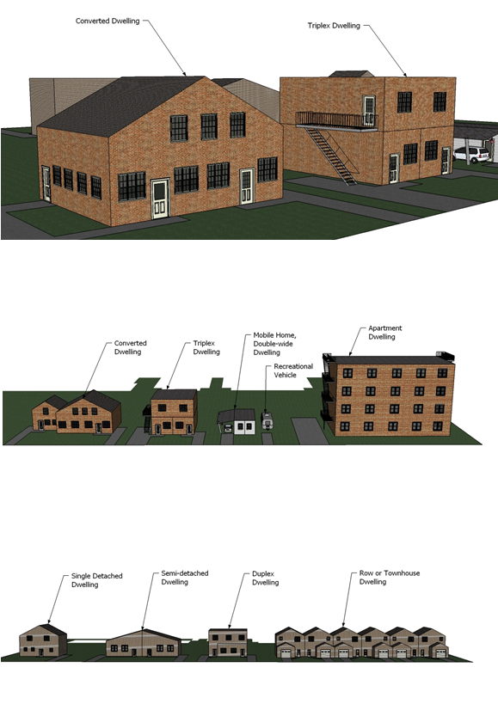

**3.65 Equipment Rental Establishment – Industrial**

Means an establishment primarily engaged in the rental of machinery, equipment, furniture, fixtures and other goods, of a size and type which should be used for business, industrial and major construction undertakings or which may involve bulk shipping of such goods, large catering undertakings, or similar non-household oriented rental functions.

3.66 Equipment Sales, Service and Repair Establishment - Industrial

Means a building or part of a building where machinery or equipment, vehicle, including commercial vehicles, and/or trailers may be sold, serviced, washed or repaired and may include an auto body shop.

**3.67 Equipment and Vehicle Storage Yard – Industrial**

Means an uncovered area which is used for the storage and machinery and equipment for use in industrial and major construction undertakings, commercial vehicles, and other similar goods requiring large areas for outside storage. Limited repair of such machinery, equipment, vehicles and goods may be permitted in a building provided such repair is clearly incidental and secondary to the storage use.

3.68 Erect

Means to build, construct, reconstruct, alter or relocate and without limiting the generality of the foregoing shall be taken to include any preliminary physical operation such as excavating, grading, piling, cribbing, filling or draining, structurally altering any existing building or structure by an addition, deletion, enlargement or extension.

3.69 Established Grade

Means the average elevation of the finished level of the ground adjoining all of the walls of the building exclusive of any artificial embankments or berms.

3.70 Existing

Means existing as of the date of the passing of this By-law.

**3.71 Farm**

Means land used for the tillage of soil and the growing of vegetables, fruits, grains, and other staple crops. This definition shall also apply to land used for animal husbandry, dairying or wood lots.

3.72 Farm Produce Outlet

Means a use accessory to a farm which consists of the retail sale of agricultural products produced on the farm where such outlet is located.

3.73 Farmer's Market

Means an establishment or premises where the farm products of a local farming community are sold at retail from covered or uncovered areas designed for individual retailers.

3.74 Fence

Means any barrier or structure constructed of chain link metal, wood, stone, metal, brick or other similar materials or combinations of such materials which is erected for the purpose of screening, safeguarding, retaining or enclosing property or delineating property lines.

3.75 Flea Market

Means a street market composed of a series of individual retailer's booths or tables where sundry, new or second-hand articles, fresh produce or preserves are offered for sale.

3.76 Floodline

Means a line established by a one in one hundred year storm which is determined by the flood plain mapping of the appropriate Conservation Authority.

3.77 Flooding Hazards

Means the inundation of areas to a shoreline or a river or stream system and not ordinarily covered by water and is described as the one hundred year flood or major storm such as the Timmins Storm (1961) transposed over a specific watershed.

3.78 Flood Plain

Means the area, usually low lands, adjoining a watercourse which has been, or may be subject to flooding hazards.

3.79 Floor Area - Gross

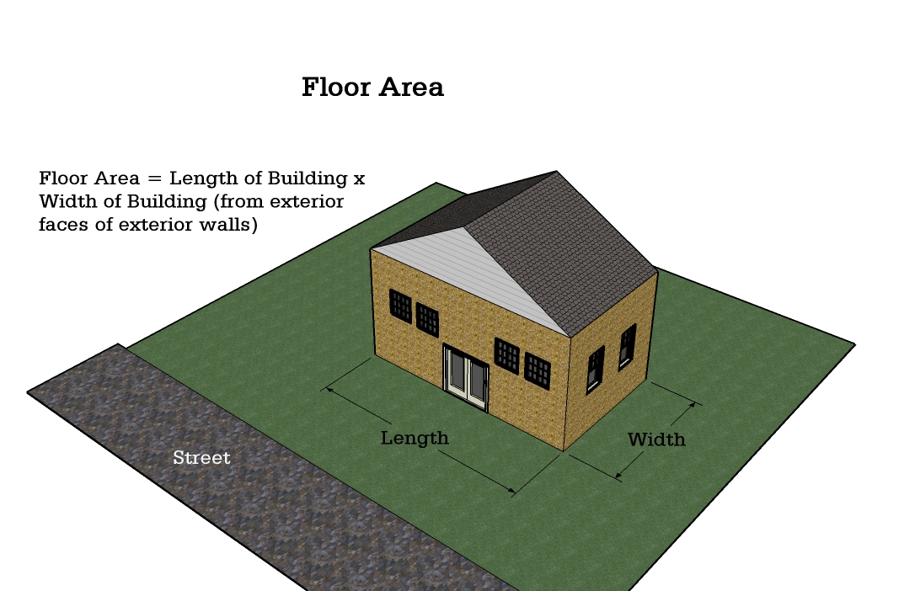Means the total area of each floor measured between the exterior faces of the exterior walls of the building and where there are no walls the total area of a floor within the outer perimeter of the floor (see illustration).

3.80 Floor Area - Net

Means usable or habitable space above or below grade, measured from the exterior face of the exterior walls of the building or structure but shall not include:

**(a)** Any private garage, porch, veranda, and unfinished basement, cellar or attic;

**(b)** Any part of the building or structure below grade which is used for building services, storage or laundry facilities; and

**(c)** Any part of the building or structure used for the storage or parking of motor vehicles.

3.81 Forestry Use

Means the general raising, management and harvesting of wood and shall include the raising and cutting of fuel wood, pulpwood, lumber, Christmas trees, other forestry products and silviculture practices.

3.82 Fuel Depot

Means land, building or structures used for the bulk storage, distribution and sale of gasoline, liquid or solid fuels or propane.

3.83 Funeral Parlour

Means a building or part of a building wherein undertaking services are offered and may include subsidiary activities such as the sale of caskets and urns, the serving of food and beverages to visitors, a chapel and funeral accessories provided such activities are clearly secondary and incidental to the main undertaking service but shall not include a crematorium.

3.84 Garage - Municipal

Means a building which is used for the storage or servicing or minor repairs of equipment essential to the actual operation of motor vehicles owned and maintained by the Township of Johnson and any Ministry or department of the Government of Ontario or Canada.

3.85 Garage - Private

Means an accessory building or portion of a main building including a carport which is designed or used for parking or storage of motor vehicles of the occupants of the premises and in which there are no facilities for repairing or servicing of such vehicles for remuneration or commercial use.

3.86 Garden Centre

Means an outdoor area primarily used for the retail of gardening equipment, products and planting materials provided it is clearly accessory to a retail store and is enclosed by a wall, a fence or other form of visual screen constructed of materials which will blend in with the associated retail store.

3.87 Gasoline Bar

Means a place for one (1) or more pump islands each consisting of one (1) or more gasoline pumps or motor fuel pumps, and which such premises may include the accessory sale of convenience items or food and which such premises shall not be used for repairs, oil changes or greasing of vehicles.

3.88 Gasoline Card Lock Facility

Means one or more pump islands designed for the retail sale of gasoline or diesel fuel using pumps which are operated automatically by credit or debit cards.

3.89 Golf Course

Means a public or private area operated for the purpose of playing golf and includes a par 3 golf course, driving range, putting green, club house but does not include a miniature course and similar use operated for commercial purposes.

3.90 Group Home

Means a single housekeeping unit in a residential dwelling, which is registered with the Municipality, in which three (3) to ten (10) persons (exclusive of supervisory staff or operating staff) live together under responsible supervision consistent with the requirements of its residents for a group living arrangement and which is licensed and/or approved under Provincial Statutes and in compliance with municipal by‑laws.

**3.91 Guest Cabin**

Means an accessory building used for guest accommodation which does not contain any cooking or sanitary facilities.

3.92 Habitable Room

Means a room in a dwelling used or intended to be used primarily for human occupancy.

**3.93 Hereafter**

Means after the date of the passing of this by-law.

**3.94 Herein**

Means in this By-law, and shall not be limited to any particular section of this By-law.

**3.95 Helipad**

Means a landing area or pad used for the landing and take-off of helicopters as further governed under the Canadian Aviation Regulation 325 under the Aeronautics Act.

**3.96 Heliport**

Means a landing area or pad used for the landing and take-off of helicopters and shall include all necessary and incidental structures, service facilities, fuelling facilities, passenger and cargo facilities and as further set out under the Canadian Aviation Regulation 325 under the Aeronautics Act.

3.97 High Water Mark

Means the mark made by the action of water under natural conditions on the shore or bank of a body of water, which action has been so common and usual and so long continued that it has created a difference between the character of the vegetation or soil on one side of the mark and the character of the vegetation or soil on the other side of the mark. Features will also include a natural line or “mark” impressed on the bank or shore or rock, or other distinctive physical characteristics.

**3.98 Home Industry**

Means any occupation which is carried out as a use accessory to the main agricultural or residential use of the property and only by a resident of/or the members of the family on the property provided that:

1. It is clearly secondary to the main agricultural or residential use and does not create nor become a public nuisance in particular in regard to noise, traffic, parking or public safety;
2. The use does not occupy more than 25% of the gross floor area of a residential dwelling unit or where located in an accessory building shall not occupy more than 93 m2 (1,000 sq. ft.);
3. This definition includes such activities as a seasonal retail outlet for farm produce produced on the farm, a workshop for wood workers, welders, painters, plumbers, other members of the trade, a machine or auto repair shop;
4. There shall be no more than two (2) commercial vehicles parked at any one time on the property;
5. There shall be no outdoor storage or display to indicate to persons outside that any part of the property is being used for other than residential or agricultural uses except for an unlit sign of not more than 1 m2 (107 sq. ft.);
6. Such home industry is not an obnoxious trade, business or manufacture;
7. Not more than three (3) persons, other than the owner are employed therein on a full-time business.

**3.99 Home Occupation**

Means the accessory use of part of a dwelling unit for pursuits conducted entirely therein by the occupant thereof and compatible with a domestic household provided that:

1. The use is clearly secondary to the use of the dwelling unit as a private residence and shall be located entirely within the dwelling unit;
2. There shall be no outdoor storage or display to indicate to person southside that any part of the property is being used for other than residential or agricultural uses except for an unlit sign of not more than 0.5 m2 (5.4 sq. ft.);
3. The use does not create or become a public nuisance in regard to noise, odour, traffic, parking or public safety;
4. The use does not occupy more than 25% of the gross floor area of the dwelling unit or 40 m2 (430 sq. ft.) whichever is the lesser;
5. The use includes a studio but does not include or permit a clinic, any retail or wholesale store or vending outlet, eating establishment, tourist establishment, convalescent home, mortuary, funeral parlour, or any use of a workshop, storage yard or plant or any of the trades.

3.100 Industrial Use

Means the use of land, building or structures for the purpose of manufacturing, assembling, making, preparing, inspecting, ornamenting, finishing, treating, altering, repairing, warehousing, or storage or adapting for sale of any goods, substances, article or thing, or any part thereof and the storage of building and construction equipment and materials as distinguished from the buying and selling of commodities and the supplying of personal services.

**Class I Industry** - ***Light Industrial Uses***

Means a place of business for a small scale, self contained plant or building which produces, manufactures, assembles or stores a product which is contained in a package and has a low probability of fugitive emissions (e.g., noise, odour, dust and vibration). Such industries operate in the daytime only with infrequent movement of products and /or heavy trucks and no outside storage. Examples include: electronics manufacturing and repair, high technology industries, furniture repair and refinishing, beverage bottling, package and crafting services, small scale assembly, auto parts supply.

**Class II Industry** - ***Medium Industrial Uses***

Means a place of business for medium scale process and manufacturing with outdoor storage of wastes or materials (e.g., it has an open process) and where there are periodic or occasional outputs of fugitive emissions (e.g., noise, odour, dust and/or vibration). Shift operations occur and there is frequent movement of products and /or heavy trucks during daytime hours. Examples include dry cleaning services, printing establishments, paint spray booths, welding shops, courier and transport services, heavy vehicle repairs, bulk fuel storage, raw product storage (e.g., aggregates, logs/lumber), warehousing, contractor’s yard.

**Class III - *Heavy Industrial Uses***

Means a place of business for uses characterized as having emissions such as noise, smoke, odour, fumes or vibrations or extensive outside storage as part of their normal operations. Such uses include sawmills, pulp and paper mills, refineries, smelting operations and similar uses which are intended to be secluded from residential or other sensitive land uses in order to limit and potential adverse effects on the environment or the surrounding areas and public health.

3.101 Institutional Use

Means land, building, structure or part thereof used by any government agency, organization, group or association, for the promotion of religious, charitable, educational, medical, benevolent objectives or public service and which is not operated for profit or gain.

3.102 Kennel

Means a place or confine where five (5) or more dogs are kept, bred or raised for any reason.

3.103 Landscaping

Means:

**(a)** A combination of trees, shrubs, flowers, grass or other horticultural elements, together with decorative stonework, paving, screening or other architectural elements, all of which is designed to enhance the visual amenity of a property and/or to provide a screen to mitigate any objectionable adjacent land use; and

**(b)** Does not include parking areas, traffic aisles or driveways or ramps for vehicles.

3.104 Laundromat

Means a building or structure where coin-operated laundry machines, using only water, detergents and additives, are made available to the public for the purpose of laundry cleaning.

**3.105 Licensed Refreshment Sales Vehicle**

Means a vehicle which is currently licensed pursuant to the *Highway Traffic Act* and which is equipped for the preparation, storage, heating, cooking, cooling or sale of foodstuffs and beverages within or from the vehicle and may include exterior seating (*e.g., picnic tables*).

**3.106 Livestock Facility**

Means one or more barns or permanent structures with livestock occupied portions intended for keeping of livestock. A livestock facility also includes all manure or material storage and anaerobic digesters.

3.107 Livestock Sales Outlet

Means a building or structure where livestock such as cattle, goats, sheep, horses or the young thereof are bought and sold.

3.108 Loading Space

Means a space or bay located on a lot or within a building which is used or intended to be used for the temporary parking of any commercial vehicle while loading or unloading goods, merchandise, or materials in connection with the use of the lot or any building thereon, and which has unobstructed access not necessarily in a straight line to a street.

3.109 Lot

Means a parcel of land which is capable of being legally conveyed in accordance with the *Planning Act*, R.S.O.1990 (see illustrations).

3.110 Lot Area

Means the total horizontal area measured within the limits of the lot lines of the lot.

3.111 Lot, Corner

Means a lot situated at an intersection of two or more streets, or at the intersection of two parts of the same street which have an interior angle or intersection of not more than one hundred and thirty-five (135) degrees.

Where such street lines are curved, the angle of intersection of the street lines shall be deemed to be the angle formed by the intersection of the tangents to the street lines, drawn through the extremities of the side lot lines. In the latter case, the corner of the lot shall be deemed to be that point on the street line nearest to the point of intersection of the said tangents.

**Definition of Lot Types**

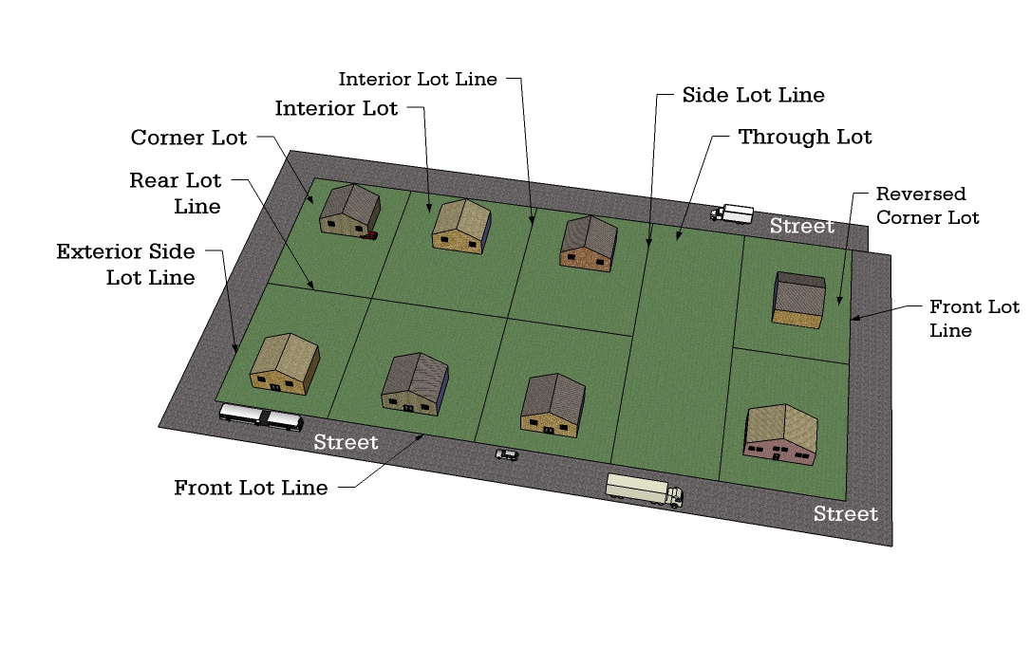

3.112 Lot Coverage

Means the combined areas of all the buildings on the Lot measured at the level of the lowest floor above grade in relationship to the area of the Lot and expressed as a percentage.

3.113 Lot Depth

Means the horizontal distance between the front and rear lot lines. If the front and rear lot lines are not parallel, "lot depth" means the length of a straight line joining the middle of the front lot line with the middle of the rear lot line. If there is no rear lot line, "lot depth" means the length of a straight line joining the middle of the front lot line with the apex of the triangle formed by the side lot lines.

3.114 Lot Coverage

Means the combined areas of all the buildings on the Lot measured at the level of the lowest floor above grade in relationship to the area of the Lot and expressed as a percentage.

3.115 Lot Depth

Means the horizontal distance between the front and rear lot lines. If the front and rear lot lines are not parallel, "lot depth" means the length of a straight line joining the middle of the front lot line with the middle of the rear lot line. If there is no rear lot line, "lot depth" means the length of a straight line joining the middle of the front lot line with the apex of the triangle formed by the side lot lines.

3.116 Lot Frontage

Means the horizontal distance between the side lot lines. Where such side lot lines are not parallel, it shall be the width of a lot measured between the intersections of the side lot lines with a line 6 m [19.6 ft] back from and parallel or concentric to the front lot line. Arc distances shall apply on curved lines.

3.117 Lot Interior

Means a lot other than a corner or a through lot which has frontage on a public street.

3.118 Lot Line

Means a boundary line of a lot.

3.119 Lot Line - Exterior Side

Means a lot line located between the front and rear lot lines and dividing the lot from a street.

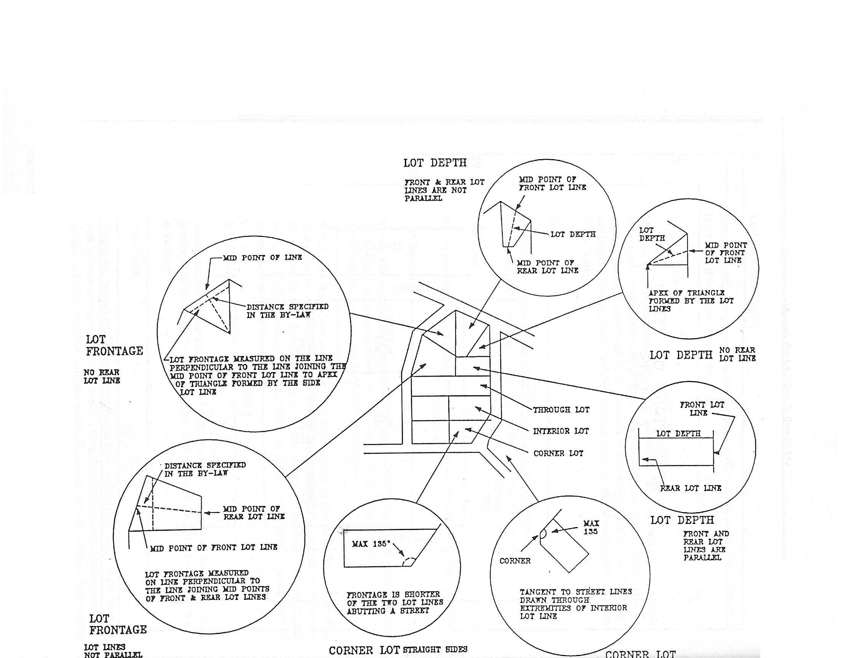

**Examples of Lot Definitions**

3.120 Lot Line, Front

Means:

1. In the case of an interior lot, the line dividing the lot from the street line;
2. In the case of a corner lot, the shorter lot line abutting a street shall be deemed to be the front lot line;
3. In the case of a corner lot with two street lines of equal lengths, the lot line that abuts the wider street, or abuts a Provincial highway shall be deemed to be in the front line, and in the case of both streets being under the same jurisdiction and of the same width, the lot line where the principal access to the lot is provided shall be deemed to be the front lot line;
4. In the case of a lot with water access only, the front lot line shall be on the water side. In the case of a through waterfront lot with water access only, the longest shoreline shall be deemed to be the front lot line; and
5. In case of a lot with frontage on a public street or private road and on a water body, the front lot line shall be measured both on the street line and on the water side.

3.121 Lot Line, Rear

Means the lot line furthest from, and opposite to, the front lot line.

3.122 Lot Line, Side Interior

Means a lot line other than a front, rear or side exterior lot line.

3.123 Lot, Through

Means a lot having a frontage on two parallel or approximately parallel streets.

3.124 Lot, Width

Means the average horizontal dimension between the two longest opposite sides.

3.125 Lumber Yard

Means a lot and accessory buildings where the primary use is the storage of construction grade wood and building supplies for sale at retail or wholesale.

3.126 Main Building

Means the building designed or used for the principal use on the lot.

3.127 Main Wall

Means any exterior wall of a building and all structural members essential to the support of a fully enclosed space of roof exclusive of permitted projections.

**3.128 Manure or Material Storage**

Means permanent storages, which may or may not be associated with a ***livestock facility*** containing liquid manure (< 18% dry matter), solid manure (≥ 18% dry matter), or digestate (< 18% dry matter). Permanent storages may include any of: locations (under, within, nearby, or remote from a barn), materials (concrete, earthen, steel, wood), coverings (open top, roof tarp, or other materials), configurations and shapes or elevations (above, below or partially above grade).

3.129 Marina

Means an establishment where boat house, boat storage, pier, dock or jetty facilities are available for any type of marine pleasure crafts and may include fuel pumps and facilities for the sale, servicing, repair and maintenance of marine craft, and buildings for the supply of marine craft accessories and may include an eating establishment. Sewage pump-out facilities for pleasure craft are also permitted.

3.130 Minimum Distance Separation Formulae I and II

Means the most contemporary version of the "Minimum Distance Separation I and II" of Ministry of Agriculture, Food and Rural Affairs (see Appendix 1).

3.131 Mobile Home

Means any dwelling that is designed to be made mobile, and constructed or manufactured to provide a permanent residence for one or more persons, but does not include a travel trailer or tent trailer or trailer otherwise designed.

3.132 Mobile Home Park

Means land which has been provided and designed for the location thereon of two (2) or more occupied mobile homes.

3.133 Modular Home

Means a single detached dwelling consisting of two or more modules which has been prefabricated or manufactured in a factory remote from the site where it is intended to be used and transported to the site for installation on a permanent foundation, but does not include a mobile home but does not include a Mobile Home, Recreational Vehicle, or a Park Model Trailer as otherwise defined.

3.134 Motel

Means a building or buildings designed or used for the accommodation of the travelling or vacationing public, containing therein three (3) or more guest rooms, each guest room having a separate entrance directly from outside and may include an accessory eating establishment.

3.135 Municipality

Means the Township of Johnson.

3.136 Non-Complying

Means any existing use, building, structure or lot which does not conform with the zone requirements and standards of this By-law (see also **Non-Conforming**).

3.137 Non-Conforming

Means any existing use, building, structure or lot which does not conform with the permitted use provisions of any Zone in this By-law (see also **Non-Complying**).

3.138 Nursery

Means land and structures used for the growing of sod, flowers, bushes, trees, or other gardening, landscaping, or orchard stock for wholesale or retail sale.

**3.139 Nutrient Unit**

Means an amount of nutrients that give a fertilizer replacement value of the lower of 43 kilograms of nitrogen, or 55 kilograms of phosphate as nutrient (as defined in Ontario Regulation 267/03 made under the Nutrient Management Act) and correlates to the number of types of livestock for a given nutrient unit.

3.140 Obnoxious Uses

Means any use which is a nuisance to the occupant or owner of any neighbouring lands or buildings by reason of the emission from the neighbouring land or building or any part thereof, or the creation thereon, of odours, gases, dirt, radiation, smoke, noise, vibration, fumes, cinders, soot, waste or water carried waste, or depositing or leaving unsightly objects or chattels thereon.

3.141 Official Plan

Means the Official Plan of the Township of Johnson or parts thereof and amendments thereto.

3.142 Office

Means a building, structure or part thereof used for the purpose of providing accommodation for the performance and transaction of business including administrative, clerical and professional activities.

3.143 Open Space

Means the open, unobstructed space on a lot including landscaped areas, pedestrian walkways, patios, pools or similar areas but not including any driveway, ramp, parking spaces or aisles, loading spaces or manoeuvring areas and similar areas.

3.144 Open Storage

Means storage or display of goods, merchandise or equipment outside of a building or structure on a lot or portion thereof. This definition shall not include the open storage of goods or equipment incidental to a residential occupancy of a lot, a parking area or parking space.

3.145 Park, Public

Means an area of land, in public ownership dedicated to recreational, cultural or conservation uses, and, for the purposes of this definition, includes a Provincial Park.

**Park - Private (see Recreational Commercial Establishment)**

**Park Model Trailer (see Dwelling - Park Model Trailer)**

3.146 Parking Aisle

Means a portion of a private parking area, or a commercial parking lot, or a private or a commercial parking structure which abuts a parking space on one or more sides and which provides access from the parking space to a street or lane and which is not used for vehicular parking.

3.147 Parking Area

Means a lot or portion thereof required in accordance with the provisions of this By-law for the temporary storage or parking of motor vehicles accessory or incidental to uses in all zones, and shall not include the storage or parking of four (4) or more motor vehicles for hire and gain, display or for sale.

3.148 Parking Lot – Commercial

Means a lot or portion thereof used for the temporary storage or parking of four (4) or more vehicles for hire and gain but does not include the sale of new or used vehicles or the storing of impounded or wrecked vehicles.

3.149 Parking Space

Means an area used for the temporary parking of one motor vehicle.

3.150 Person

Shall include an individual, an association, a chartered organization, a firm, a partnership, a corporation, an agent or trustee and the heirs, executors or other legal representatives of a person to whom the context can apply according to law.

3.151 Personal Service Establishment

Means an establishment wherein a personal service is performed. This definition may include a barber shop, beauty salon, shoe repair, photographic store, laundromat or a dry cleaning distribution station or a similar use.

3.152 Place of Amusement

Means an establishment operated for commercial gain or profit wherein amusement facilities are provided such as a video arcade or penny arcade, billiard or pool room, pinball machines and video games but shall not include a drive-in theatre.

3.153 Place of Assembly

Means a building specifically set aside for and primarily engaged in the operation of arts and craft shows, trade fairs, fashion show, public meetings, banquets, conference meetings and similar activities.

3.154 Place of Worship

Means a building or an open area dedicated to religious worship.

3.155 Playground

Means a park or part thereof which is equipped with active recreational facilities oriented to children.

3.156 Porch

Means a single storey roofed structure which is structurally dependent on and projecting from a dwelling with walls that are open and unenclosed but may contain mesh screening for insects and is used only as an outdoor unwinterized living area but does not include a deck as defined.

3.157 Portable Asphalt/Concrete Plant

Means a facility with equipment designed to heat and dry aggregate and to mix aggregate with bituminous asphalt to produce asphalt paving material or a plant designed to produce concrete and includes stockpiling and storage of bulk materials used in the process, which is not of permanent construction but is designed to be dismantled and moved to another location as required. Portable asphalt plants/concrete plants must comply with the Ministry of the Environment's separation distances and must obtain a certificate of approval from the Ministry of the Environment.

3.158 Printing and Publishing Establishment

Means a building or part thereof used primarily for printing, regardless of the method, and publishing of newspapers, periodicals, books, maps and similar publications and also includes the sale and servicing of printing and duplicating equipment.

3.159 Private Club

Means a building or part of a building used as a meeting place by an association of persons who are bona fide members, which owns, hires or leases the building or part thereof, the use of such premises being restricted to members and their guests for social, cultural, recreational, business or athletic purposes.

3.160 Private Road

Means a private right-of-way over private property which affords access to at least two (2) abutting lots and which is not maintained by a Public Authority.

3.161 Public Access Point

Means public land designated by the appropriate authority and developed and maintained by the authority as a public access to a navigable water body.

3.162 Public Authority

Means the Township of Johnson and any Boards or Commissions thereof and any Ministry or Department of the Governments of Ontario or Canada, or other similarly recognized public utility or agencies established or exercising any power or authority under any special or general statute and includes any committee or local authority established by By-law of Council.

3.163 Public Street

Means a public or common highway affording principal means of access to abutting properties which has been assumed by a public authority.

3.164 Public Utility Installation

Means:

1. Any building, structure, plant and/or equipment, essential to the operation of a public utility or service; and/or
2. Which is operated by or on behalf of any of the following:

* Great Lakes power Corporation
* Algoma Power
* Bell Canada
* Hydro One
* Ontario Power Generation
* Hydro One Networks
* A rail line
* A fuel transmission company
* A cablevision company
* A telecommunications company
* Any company which is incorporated to provide an essential utility facility or service whether federally or provincially incorporated, or which the Government of Canada, the province of Ontario, the Township of Johnson operates or has operated for them on their behalf (*e.g. OCWA*)

3.165 Quarry or Pit

Means any open excavation made for the purpose of removing any soil, earth, clay, marl, sand, gravel, consolidated or unconsolidated rock or mineral in order to supply material for construction, manufacturing or industrial purposes but shall not include an excavation incidental to the erection of a building or a structure for which a building permit has been granted to the Corporation, or an excavation incidental to the construction on any public works.

3.166 Recreational Commercial Establishment

Means an establishment, premises, or building where any recreational, social or cultural uses are operated commercially for profit on lands in private ownership, such as health clubs, golf courses, open or enclosed skating or curling rinks, open or enclosed pools, open or enclosed badminton or tennis courts, squash courts, bowling alleys, gymnasia, band shell or open theatre, and other similar uses.

3.167 Recreational Vehicle

Means any vehicle constructed that is suitable for being attached to a motor vehicle for the purpose of being drawn or is propelled by the motor vehicle and is capable of being used for the living, sleeping or eating accommodation of persons on a temporary, transient or short term basis, even if the vehicle is jacked up or its’ running gear is removed. A recreational vehicle does not include a mobile home as defined in the *Planning Act*, a park model trailer or a manufactured homeas governed by the *Building Code Act.*

This definition does not apply to prevent the storage of boats, boat or vehicle trailers, personal water craft, snowmobiles, all terrain vehicles (ATVs) or other recreational equipment normally stored or parked on a lot.

3.168 Recreational Vehicle Sales and Storage and Repair

Means a building and/or lot which are used for the repair, display, storage and/or sale of boats, trailers, campers, snowmobiles, ATVs and other recreational vehicles.

3.169 Redevelopment

Means the removal or rehabilitation of buildings or structures and the construction, reconstruction or erection of other buildings or structures in their place.

3.170 Registered Plan

Means a plan legally registered as per the Registry Act or the Land Titles Act.

3.171 Restaurant

Means a building or structure where food is prepared and offered for sale to the public for consumption within or outside the building or structure.

3.172 Retail Store

Means a building wherein goods, wares, merchandise, substances or articles are offered for sale to the general public, and may include the limited storage of goods, wares, merchandise, substances or articles, and shall not include any other use defined herein.

**Road (See Public Street)**

3.173 Salvage Yard

Means a lot and/or building or portion thereof where used goods, wares, merchandise, articles, motor vehicles, machinery or parts thereof are processed or sold for further use, dismantled or abandoned or for the sale, dismantling, demolition or abandonment of automobiles or other vehicles, machinery or parts thereof. This definition may include a junk yard, a scrap metal yard, a recycling depot and an automobile wrecking yard on the premises.

3.174 Sauna

Means an accessory building or structure wherein facilities are provided for the purpose of a steam bath and may include a change room and shower.

3.175 Sawmill or Planing Mill

Means a building, structure or area where timber is cut or sawed, either to finished lumber or as an intermediary step.

**3.176 Showroom**

Means a part of a building primarily used for the display of samples, patterns or other goods and wherein orders are taken for merchandise which is stored in bulk or manufactured in part of the same building, generally for future delivery to its consumers

3.177 School

Shall mean a public educational establishment operated by a Board of Education.

3.178 School, Commercial or Private

Means an educational establishment, other than a School, wherein teaching or instruction is offered for gain in such fields as academics, dancing, music, art, sports, business or trade, and any other such specialized school conducted for gain, and also includes such fields as a studio for photography and arts and crafts.

3.179 Seating Capacity

Means the number of persons which can be accommodated in a building or structure or part thereof in a seated position on chairs, benches, forms or pews.

**3.180 Self-Storage Facility**

Means a building or part of a building used for the purpose of renting or leasing individual secured storage units to tenants who are to have access to such units for the purpose of storing and removing property. Property may include general merchandise, furniture, household items, unlicensed and licensed vehicles, equipment, tractors and recreational vehicles (boats, motor homes, trailers). Explosives, radioactive materials, flammable or hazardous chemicals or goods which produce noxious odours are prohibited.

3.181 Service Outlet

Shall mean a building whether in conjunction with a retail store or not, used for the repair or servicing of goods, commodities, articles or materials, but not the manufacturing thereof. Automotive repairs and services are not permitted under this definition.

3.182 Setback

Shall mean:

1. With reference to a road or street, the least horizontal distance between the front lot line and the nearest building line; ~~and~~
2. With reference to a water body, the least horizontal distance between the high water mark of the water body and the nearest building line.
3. With reference to a ***building***, ***structure*** or land ***use*** and not applicable under paragraph (a) or (b), shall mean the least horizontal distance from the ***building***, ***structure*** or land ***use*** in question.
4. With reference to a private road, the least horizontal distance between the shoulder of the travelled portion of the road and any building or structure, or the limit of the road as shown and measured on a survey.

3.183 Shooting Range or Rifle Club

Means land buildings, structures or premises used for recreational target practice, skeet shooting, gun or hunter safety instruction and are commercially operated by a club or organization.

3.184 Shoreline, High Water Mark or Waterbody

Means the mark made by the action of water under natural conditions on the shore or bank of a body of water which action has been so common and usual that it has created a difference between the character of the vegetation or soil on the other side of the mark.

5 m

5 m

3.185 Sight Triangle

5 m

5 m

Means a triangular space, free of buildings, structures and obstructions, formed by the street lines abutting a corner lot and a third line drawn from a point on a street line to another point on a street line, each such point being the required sight distance from the point of intersection of the street lines as specified in this by-law (see illustration).

5 m

5 m

3.186 Sign

Shall mean any writing, letter work or numeral, any pictorial representation, illustration, drawing, image or decoration, any emblem, logo, symbol or trademark or any device with similar characteristics which:

**(a)** Is a structure, or part of a structure, or which is attached thereto or mounted thereon; and

**(b)** Which is used to advertise, inform, announce, claim, give publicity or attract attention.

3.187 Storey

Means that portion of a building other than a cellar or basement included between the surface of any floor and the surface of the floor, roof deck, ceiling or roof immediately above it.

3.188 Street Allowance

Shall have a corresponding meaning to that of Public Street or Private Road.

3.189 Street Line

Means the limit of the road or street allowance and is the dividing line between a lot and a Public Street or Private Road.

3.190 Structure

Means anything constructed or erected, the use of which requires location on the ground or attached to something having location on the ground and, without limiting the generality of the foregoing, includes a recreational vehicle but does not include a fence~~s~~.

3.191 Studio

Means a building or part thereof used,

**(a)** As the workplace of a photographer, artist, or artisan; or

**(b)** For the instruction of art, music, languages or similar disciplines.

3.192 Swimming Pool

Means an open or covered pool which is at least 50 cm [19.6 in] in depth, and may include a hot tub or whirlpool or jacuzzi.

3.193 Tavern or Roadhouse

Shall mean a "tavern" as defined by the *Liquor License Act.*

**3.194 Tourist Commercial Retail Store**

Means a retail store catering principally to the tourism industry.

3.195 Tourist Lodge

Means a building or buildings designed or used for the accommodation of the travelling public or vacationing public and may include a campground, motel, lodge, self-contained rental cottage or cabins where more than 3 such rental units occupy the same property, including accessory uses such as dining, meeting and beverage rooms and similar uses.

3.196 Tourist Outfitters Establishment

Means an establishment which operates throughout all or part of a year which may or may not furnish overnight accommodation and facilities for serving meals and furnishes equipment, supplies or services to persons in connection with angling, hunting, camping or other similar recreational purposes.

3.197 Township

Means the Corporation of the Township of Johnson.

**Trailer** **(see Recreational Vehicle)**

3.198 Transportation Depot

Means land, or a structure or a building where commercial vehicles are kept for hire, rental and/or lease, or stored and/or parked for remuneration and/or from which such vehicles are dispatched for hire as common carriers and where such land, structure or building may be used for the storage and/or distribution of goods, wares, and merchandise.

3.199 Transfer Station

Means land, buildings or parts of buildings used for the temporary storage, and subsequent dispersal of garbage, refuse, domestic or industrial waste, exclusive of liquid industrial waste or hazardous waste.

3.200 Use

Means the purpose for which a lot or a building or a structure is designed, arranged, occupied or maintained.

3.201 Veterinary Establishment

Means a building or part of a building used by a veterinary surgeon where animals, birds or other livestock are treated and where domestic animals and/or birds may be kept for treatment and may include a kennel.

3.202 Video Rental Outlet

Means a building or part of a building wherein the primary use is the rental of video tapes and may include the rental of video cassette recorders, video cameras and video games.

3.203 Warehouse

Means a building or structure or portion thereof used or intended to be used for the bulk storage of goods, merchandise, or material.

3.204 Waste Management Facility

Means a site which is licensed or approved by the Ministry of the Environment and/or its agents where garbage, refuse, domestic or industrial waste, excluding radioactive or toxic chemical wastes is disposed of or dumped. This definition shall include compost sites, septage disposal sites and lagoons, wastewater stabilization lagoons, waste transfer stations and recycling depots.

3.205 Water Frontage

Means a lot which has one or more lot lines abutting a navigable watercourse, bay or lake.

3.206 Water Body

Means any bay, lake, river, natural watercourse or canal but excluding a drainage or irrigation channel.

3.207 Wayside Pit

Means land from which unconsolidated aggregate is removed by means of open excavation for use in a public undertaking.

3.208 Wayside Quarry

Means a place from which consolidated aggregate is removed by means of open excavation for use in a public undertaking.

**3.209 Welding Shop**

Shall mean a building or structure or part thereof where metal products are joined, repaired or shaped by welding but no mass productions shall be involved.

3.210 Wetland

Means lands that are seasonally or permanently covered by shallow water, as well as lands where the water table is close to or at the surface. In either case the presence of abundant water has caused the formation of hydric soils and has favoured the dominance of either hydrophytic or water tolerant plants. The four major types of wetlands are swamps, marshes, bogs and fens.

Lands being used for agricultural purposes, that are periodically "soaked" or "wet", or which no longer exhibit wetland characteristics are not considered to be wetlands for the purposes of this definition.

**3.211 Workshop or Custom Workshop**

Means a building, structure or part thereof where manufacturing is performed by a tradesman, requiring manual or mechanical skills and may include a carpenter's shop, a locksmith's shop, a gunsmith's shop, a tinsmith's shop, a commercial welder's shop or similar uses.

3.212 Yard

Means the area between a main wall of a building and a lot line that, except for landscaping or accessory buildings and projections specifically permitted elsewhere in this by-law, is unobstructed above grade (see illustration).

3.213 Yard, Front

Means a yard extending across the full width of the lot between the front lot line and a line drawn parallel or concentric thereto and through the point of the main wall of a main building closest to the front lot line (see illustration).

3.214 Yard, Rear

Means a yard extending across the full width of the lot between the rear lot line and a line drawn parallel or concentric thereto and through the point of the main wall of the main building closest to the rear lot line. Where there is no rear lot line, the Yard, Rear shall be measured from the intersection of the side lot lines to the closest point of the main wall of the main building (see illustration).

3.215 Yard, Side

Means a yard extending from the front yard to the rear yard between the side lot line and a line drawn parallel or concentric thereto and through the point of the main wall of a building closest to the side lot line (see illustration).

3.216 Yard, Side Exterior

Means a side yard adjacent to a public street (see illustration).

3.217 Yard, Side - Interior

Means a side yard other than an exterior side yard (see illustration).

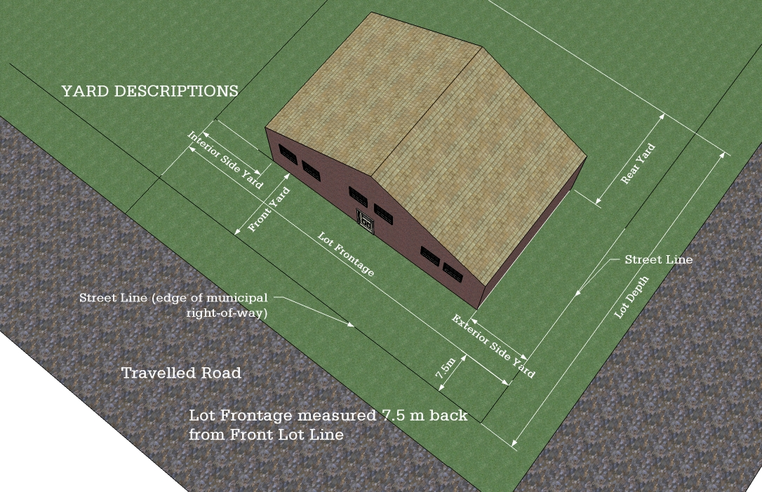

3.218 Zone

Means a designated area of land use demarcated on the Schedules attached hereto.

3.219 Zone Regulation

Means any provision of this By-law which is listed under the heading "Zone Regulations" and includes anything which is applicable to the zone or use.

3.220 Zoning Administrator

Means the officer or employee of the Corporation, charged with the duty of enforcing the provisions of this By-law.

|  |
| --- |
| Section 4 GENERAL PROVISIONS |

**Explanatory Note**

*The General Provisions section of the By-law states the regulations which apply regardless of the specific zoning (Section 5). Whereas the zones provide site specific controls corresponding to such items as permitted uses and locational restrictions, the General Provisions provide regulations more general in nature, applying to a variety of uses regardless of zoning.*

## 4.1 Accessory Buildings, Structures and Uses

4.1.1 Where a lot is devoted to a permitted use, customary accessory uses, buildings and structures are authorized provided that (see illustration):

**(a)** All accessory uses, buildings and structures to a permitted principal use shall be located on the same lot and in the same zone as the principal use. No accessory building shall be erected prior to the erection of the main building on the same lot, except where it is necessary for the storage of the tools, and materials for the use in connection with the construction of the main building or structure, and no such accessory building shall, prior to the erection of the main building, be used for any purpose other than storage and shall not be used for habitation unless otherwise permitted by this By-law;

**(b)** The use of any accessory building for human habitation is not permitted except where specifically listed as a permitted use;

**(c)** No accessory use shall be erected closer to the front lot line or the exterior side lot line than the minimum front yard and external side yard setbacks required for the main building.

**(d)** No accessory building or structure shall be erected closer than 1.5 m [4.9 ft.] to any interior side lot line or rear lot line or the main;

This provision shall be exempted:

1. For a partially enclosed shelter for use by children waiting for a school bus, if such use is located in a rural zone and provided the front yard setback for the shelter is 3 m [9.84 ft];
2. For any farm produce outlet located in a rural zone provided the front yard setback for any sales structure is 3 m [9.84 ft];
3. For a lot in a rural zone to the extent that accessory uses, buildings and structures may be located in the front yard provided that the minimum front yard depth for the main buildingshall be double the front yard depth otherwise required for the zone, provided that the accessory uses, buildings or structures shall be in compliance with the front yard, interior and exterior side yard requirements for the main buildings or structures in the zone and provided that all other relevant provisions of this By-law are complied with;
4. For open or outdoor storage, where permitted in this By-law; and
5. For a gate house used for security for a gated residential complex, or a permitted non-residential use provided the front yard setback for the gate-house is 3 m [9.84 ft].

**(e)** Common semi-detached garages or carports may be centered on the mutual side lot line.

**(f)** Accessory uses, excluding open swimming pools, shall not cover more than 10 % of the lot area in any Residential zone or 50% of the maximum lot coverage permitted in any non-residential zone.

**(f)** Notwithstanding **Section 4.1.1 (c)** and **(d)** above, a boat house, dock or wharf may be located in the front yard, side yard or rear yard where a lot abuts a navigable waterway, provided that the approval of any governmental authority having jurisdiction has been obtained and provided that the boat house, dock or wharf is located not closer than 5.0 m [16.4 ft.] to the nearest adjacent lot line and does not encroach on adjacent frontage when the lot boundaries are extended into the water (see illustration)

4.1.2 Private swimming pools, both above-ground and in-ground both open and covered, shall be permitted subject to any By-law of the Township regarding swimming pools and the following requirements:

**(a)** Open Pools

1. Open Pool areas shall be totally enclosed by a fence constructed of suitable materials, having a minimum height of 1.5 m [4.9 ft] with a self-locking gate;
2. The maximum height of an above-ground pool shall not be more than 2 m [6.56 ft.] above grade and shall not be located within 5 m [16.4 ft.] of the fence;
3. Any building or structure, other than a dwelling, required for changing clothing or pumping, filtering or storage or any similar purposes shall comply with the provisions respecting accessory uses and structures; and
4. No part of an Open Pool including an associated apron or platform which is in a front or side yard shall be constructed closer to a street line than the requirements for a main building in the zone within which it is located nor closer to the lot line in a rear yard than the minimum distance required for an accessory use or structure.

**(b)** Covered Pools

Covered pools shall conform with the accessory building requirements contained in **Section 4.1.1** where the pool is built in an accessory building.

**(c)** Pools in the Flood Plain

The establishment of any swimming pool in an identified flood plain area shall be subject to the approval of the Ministry of Natural Resources.

**Example of Accessory Building and Use**



**4.1.3 Bed and Breakfast**

A bed and breakfast establishment shall be permitted in any residential zone in a single detached dwelling subject to the following requirements:

1. That the use of the dwelling does not change the residential character of the dwelling;
2. That the requirements for the provision of off-street parking spaces can be met;
3. That the requirements of the local Health Unit, where applicable, can be met;
4. That one sign only shall be permitted provided the sign area does not exceed 1.2 m2 [12.9 ft2], does not flash or oscillate, does not exceed a height of 1.5 m [4.92 ft] if a free standing sign, shall not obstruct any sight triangle, and has a minimum setback from any lot line of 1 m [3.28 ft]; and
5. That the bed and breakfast shall not be combined with any other residential use except a single detached dwelling in which it is located.

## 4.2 Auto Service Station, Gasoline Bar, Car Washing

Despite any other provisions contained in this By-law, for all zones within which an automobile service station, gasoline bar, and/or car washing establishment is permitted the following shall apply:

**(a)** Gasoline Pump Island Location

The minimum distance between the gasoline pump island, pumps and their related overhead canopies and any pump shall be 10 m [32.8 ft] from any lot and street line.

**(b)** Where a car washing establishment abuts a residential zone, the following requirements shall apply:

1. Notwithstanding any other requirements of this by-law, for a lot abutting lands zoned for residential use, a car washing establishment shall not be permitted on any lot having a lot area of less than 0.4 ha [1 ac.] and shall be located on such lot no closer than 20.0 m [65.6 ft.] to any lot line abutting such residential zone.
2. No washing or drying operations shall be permitted except within the building designed for the purpose of the car washing establishment.
3. The building shall be so designed that vehicles will egress from the building after washing and drying operations by means of a door located in the wall of the building which is furthest removed from the lot line(s) which abut lands which are zoned for a residential use.
4. A landscaped area of not less than 6.0 m [19,6 ft.] in depth from the lot line(s) which abut lands which are zoned for a residential use shall be used for no other purpose than landscaping, including the planting of trees and shrubs and the erection and maintenance of screening, walls and fences.

1. Separation of Propane Tanks and Natural Gas Tanks

No person shall erect or use a tank for the storage of propane for sale at an automobile service station or gas bar or on any other property where vehicle fuel may be dispensed unless a license has been obtained from the Ministry of Consumer and Commercial Relations and the location is in compliance with the requirements under the *Ontario Propane Code*, and the *Gasoline Handling Act.*

**(d)** The width of any entrance or exit combined entrance or exit measured at the front lot line or exterior side lot line shall not be greater than 9 m [29.5 ft] and there shall not be more than 2 accesses from any one street which adjoins the lot.

**(e)** The minimum distance of any access from a street intersection shall be 12 m [39.4 ft] and the minimum distance between accesses shall be 9 m [29.5 ft. ].

## 4.3 Buildings to be Moved

No building or structure shall be moved within the limits of the Township or shall be moved from outside the Township into the Township unless the building or structure is a permitted use and satisfies all the requirements of the zone in which it is to be located and then only after a permit has been obtained from the Chief Building Official.

## 4.4 Camp

A permitted camp may be located on any lot of record provided such building is separated a minimum of 500 m [1,640.4 ft.] from any existing residential dwelling unit. No minimum lot area or frontage requirements shall apply to a permitted camp. The maximum gross floor area of a camp shall be 37.2 m2 [400 ft.2].

## 4.5 Change of Use

A use of lot, building or structure which, under the provisions hereof is not permissible within the zone in which such lot, building or structure is located, shall not be changed except to a use which is permissible within such zone.

## 4.6 Cumulative Standards

Despite anything contained in this By-law, where any land, building or structure is used for more than one purpose, all provisions of this By-law relating to each use shall be complied with, but no dwelling shall be located within 3.0 m (9.8 ft.) of any other building on the lot except a building accessory to such dwelling.

## 4.7 Established Building Line in Built-up Area

Notwithstanding any other provision or regulation of this By-law, in any Residential Zone, the front yard setback for a residential building to be constructed between existing buildings or adjacent to existing buildings which are separated by no more than 60 m [196.8 ft.], may be reduced to a setback equal to the average setback of the said existing residential buildings or 6 m [19.6 ft.] whichever is the greatest.

## 4.8 Day Nurseries

Private home day nurseries are permitted in all zones where residential uses are permitted as a principal use. Such day nurseries shall comply with the provisions of the *Day Nurseries Act*.

## 4.9 Exception Zone

Where a zone symbol is followed by the suffix "-X" this shall mean that a specific exception is being made to one or more of the standards of that zone for a specific area governed by the By-law. All other provisions of the By-law shall continue to apply.

A number after the "-X" (e.g., R-X1) indicates the order of the various exception zones.

## 4.10 Farm Use

Nothing contained in this By-law shall prevent the continued use of any land, building or structure for farming or agricultural purposes as defined, or any extension or addition of such use provided that any additions or extensions of such use shall comply with the requirements of the Minimum Distance Formulae I and II of this By-law (as set out in Appendix 1) and the applicable requirements of the Rural (R) Zone, Agricultural (A-1) and Agricultural (-2) Zones.

## 4.11 Flood Plain

1. Notwithstanding any other provisions of this By-law, no dwelling shall be constructed or extended or expanded along the Lake Huron Shoreline below geodetic elevation of 178.3 m [584.9 ft.] except as otherwise permitted in -subsection 4.11.
2. Notwithstanding any other provision of this By-law, no building or structure except a boat house, dock or wharf shall be erected closer than 15 m [49.2 ft.] from any shoreline, water body or high water mark.
3. Modification of the flood plain through filling, excavation or by other means is prohibited unless otherwise permitted by the Ministry of Natural Resources.
4. No person shall use any land or erect, alter or use any building or structure in the Flood Plain except in accordance with the following provisions:

4.11.1 Permitted Uses

1. Buildings or Structures Intended for Flood or Erosion Control or Slope Stabilization;
2. All Buildings and Structures in Existence on the Day of the Passing of this By-law;
3. Conservation Uses;
4. Forestry Uses;
5. Parks without Buildings or Structures;
6. Hydro-electric generating facilities

4.11.2 Prohibited Uses

1. An institutional use;
2. Any essential emergency service such as those provided by fire, police and ambulance stations and electrical substations which would be impaired during an emergency as a result of flooding, the failure of flood proofing measures and/or protection works and/or erosion; and
3. Any building, structure or use which involves the disposal, manufacture, treatment or storage of hazardous substances defined as materials that are ignitable, corrosive, reactive, radioactive or pathological and would normally pose a danger to public health, safety and the environment.

## 4.12 Frontage on a Public Street or Private Road

4.12.1 No person shall erect any building or structure in any zone unless the lot upon which such building or structure is to be erected has sufficient frontage on a public street or private road as per the requirements of the respective zone within which the lot is situated except:

**(a)** Where such use or dwelling is located on an island provided there is adequate access to public parking or an easement registered on title providing for off-street parking in lieu of public parking and docking facilities on the mainland;

**(b)** Where such dwelling is located on an existing private road and does not require an extension of the private road and is located on an existing lot of record;

**(c)** A camp;

**(d)** A resource related use on Crown Land;

**(e)** A communications facility;

**(f)** A public utility;

**(g)** A wayside pit or quarry; and

1. Any passive outdoor recreational use or activity such as skiing, snowmobiling, hiking, mountain biking or similar activities.

For subsections (c), (e), (f), and (g), where frontage is not on a public street or a private road, access shall be provided by a legal right-of-way to the property.

4.12.2 Exception for Existing Agreements

**(a)** Despite **Section 4.12.1**, where a maintenance agreement exists between the municipality and a land owner and is registered on title, frontage on an unopened or unmaintained public right-of-way shall be deemed to conform to the provisions of this section, provided that such frontage is in conformity with the standards set out in the corresponding zone or any exception thereto;

**(b)** Despite **Section** **4.12.1**, where an access agreement registered on title between or amongst landowners provides for a right-of-way to an existing lot of record, or the lot of record has water access only, the access requirements shall be deemed to conform with the provisions for access of this By-Law.

4.12.3 Ministry of Transportation Access Requirements

In addition to all the municipal requirements, all development adjacent to Provincial Highways is also subject to the requirements and permits of the Ministry of Transportation.

## 4.13 Group Homes

Group Homes shall be permitted in all zones that allow residential uses (i.e. R1, MR, RR, SR, R), provided that they are provincially licensed and/or approved.

## 4.14 Helipad, Heliport

Where a Helipad or Heliport is permitted in this By-law, the following provisions shall apply:

1. The setback between the edge of the helipad and the main wall or receptor of a *sensitive land use* shall be determined by a noise and vibration study undertaken by a professional competent in undertaking such studies. Reference shall be made to Ministry of the Environment Guideline “Noise Assessment Criteria in Land Use Planning LU-131”;
2. The setback between the edge of the helipad and any non-residential use not classified as a *sensitive land use* shall be 200 m [656.2 ft]; and

The classification, design, construction and operation of a Heliport shall comply with Standard 325, Heliports, Part III, Canadian Aviation Regulations issued under the Aeronautics Act, administered by Transport

## 4.15 Illumination

Illumination of buildings and grounds shall be permitted provided that:

**(a)** Illumination shall not cause direct or indirect glare on a street that may interfere with traffic or pedestrian safety;

**(b)** Illumination shall not consist of a colour or be so designed or located that it may be confused with traffic signals; and

**(c)** Illumination shall not cause direct or indirect glare on land or buildings in any zone in which residential uses are permitted.

## 4.16 Kennel

A kennel shall only be permitted as an “Exception Zone” to the Rural Zone.

## 4.17 Land Suitability for Use and Organic Soils

Despite any other provision of this By-Law, no habitable building or structure shall be constructed, erected, altered or used on land which, by reason of its rocky, low lying, marshy, unstable character or which is located or may be located on organic soil unless the proponent or applicant for development can demonstrate through professionally acceptable engineering techniques that the physical constraint can be mitigated or overcome and that the requirements of the *Ontario Building Code* with respect to construction and the requirements of the *Ontario Water Resources Act* and the *Ontario Building Code* with respect to the installation of an individual on-site sewage and water system can be met.

## 4.18 Licenses, Permits and Other By-laws

Nothing in this By-law shall exempt any person from complying with requirements of the Building By-law or any other By-law in force within the Township or from obtaining any permit, license, permission, authority or approval required by this or any other By-law of the Township of Johnson or by any other law in force from time to time.

## 4.19 Loading Space Requirements

For every building or structure erected for a commercial or industrial use, involving the frequent shipping, loading or unloading of persons, animals, wares, merchandise or other goods, there shall be provided and maintained loading spaces in accordance with the following requirements:

1. Each loading spaceshall have a minimum height clearance of 4.25 m [13.9 ft.] and shall be at least 3.75 m [12.3 ft.] in width by 7.5 m [24.6 ft.] long if situated inside of or at right angles to a building or structure or 3.75 m [12.3 ft.] wide by 9.0 m [29.5 ft.] long if situated parallel to the wall of a building or structure.

**(b)** Loading spaces shall be located in a building or structure, an open rear yard or an open side yard on the same lot on which the main use is located and the loading space is required, provided such a space is in an area whose distance from a lot line to the building or structure is not less than 7.5 m [24.6 ft.] and shall have unobstructed access to and from a street by a driveway, lane or aisle of a minimum width of 6 m [19.7 ft.].

**(c)** The number of required loading spaces shall be based on net floor area of the building or structure as follows:

**(i) Commercial Uses**

|  |  |
| --- | --- |
| **Net Floor Area** | **Minimum Required Loading Spaces** |
| 0 - 200 m2 | 0 |
| [0 - 2,152.78 ft2] |
| 200.01 - 500 m2 | 1 |
| [2,152.89 - 5,381.96 ft2] |
| over 500 m2 | 2 |
| [over 5,381.96 ft2] |

**(ii) Industrial Uses, excluding mineral mining operations and mineral aggregate operations**

|  |  |
| --- | --- |
| **Net Floor Area** | **Minimum Required Loading Spaces** |
| 0 - 500 m2 | 1 |
| [0 – 5,382.1 ft.2] |
| 500.01 - 2,000 m2 | 2 |
| [5,382.1 – 21,505 ft.2] |
| over 2,000 m2 | 3 |
| [over 21,505 ft.2] |

1. The loading space requirements stated in paragraph (c) shall not apply to buildings or structures in existence as of the date of passing of this By-law but shall apply to areas of any expansion or enlargement to such buildings or structures for which building permits have been issued after the date of passing of this By-law.

## 4.20 Mine Hazards

No lands identified as having a mine hazard shall be used unless the mine hazard has been rehabilitated or measures taken to mitigate known or suspected hazards. Any required rehabilitation or mitigation measures shall be undertaken using acceptable engineering practices.

## 4.21 Minimum Distance Separation and Special Setbacks

No person shall use any land, building or structure for a sensitive use (e.g., residential use, daycare centre, educational or health facility) unless it complies with the following minimum distance separations, influence areas or special setbacks except where such distances have been waived or reduced by a public authority, where upon the revised distance, influence area or setback shall apply. Distances, influences areas or setbacks shall be measured as set out for the respective requirement.

**(a) Setback from Highway 17 or any Active Rail Line.**

The setback shall be as determined by a noise and/or vibration study if such is required by Council and shall be generally measured from the point source of the emission to the property line of the receptor land use.

**(b) Waste Management Facility**

1. The influence area shall be 500 m [1,640 ft.] from a sensitive land use (e.g. residential use, daycare centre, educational or health facility) measured from the boundary of the (licensed) fill area to the nearest property line of the sensitive use. Within the influence area, no sensitive land use shall be permitted unless an Environmental Impact Assessment is undertaken, to the satisfaction of the approval authority, to demonstrate that the proposed development will not negatively be impacted by the waste management facility (e.g., leachate migration, methane gas, rodents, vectors, vermin, odour, litter, noise, etc.);
2. No development or land use shall be permitted within 30 m [98.4 ft.] of the (licensed) fill area of an active waste management facility;
3. No waste management facility shall be permitted within 30 m [98.4 ft.] from any watercourse, lake or pond;
4. No waste management facility shall be permitted within 100 m [328 ft.] of any lot line which abuts an existing dwelling, school, health care facility or place of worship or vice versa or as otherwise may be prescribed by the Ministry of the Environment.

In addition no waste management facility shall be permitted on land covered by water or in any area subject to flooding (see **Section 4.11.2**).

**(c) Pits and Quarries**

The minimum separation distance between a sensitive land use (e.g., residential use, daycare centre, educational or health facility) and the boundary of a Mineral Extraction Area of a pit shall be 70 m [230 ft] or 300 m [984 ft] for a quarry. Within an influence area of 300 m [984 ft] from the boundary of a Mineral Extraction Zone Boundary for a pit or 1,000 m [3,280 ft] for a quarry, respectively, no sensitive land use shall be permitted unless appropriate measures have been undertaken to mitigate adverse or potential adverse impacts such as visual impacts, noise, dust, traffic or ground water quality or quantity. Adverse effects may be addressed by means of a phasing plan, rehabilitation plan, landscaping berming, specified truck routes or other measures acceptable to Council.

**(d) Industrial Uses**

1. Class I Industrial: Includes light industrial uses defined as a place of business for a small scale, self-contained plant or building which produces/stores a product which is contained in a package and has low probability of fugitive emissions e.g. noise, dust, odour and/or vibration. There are daytime operations only, with infrequent movement of products and/or heavy trucks and no outside storage. Examples include electronics manufacturing, furniture repair, auto parts supply, packaging and crafting services. The minimum separation distance from a sensitive land use (e.g., residential use, daycare centre, educational or health facility) shall be 20 m [65.6 ft.] measured from property line to property line while the influence area shall be 70 m [230 ft.];
2. Class II Industrial: Includes a place of business for medium scale processing and manufacturing with outdoor storage of wastes or materials and or periodic outputs of minor annoyance. There are occasional outputs of either point source or fugitive emissions for noise, odour, dust and/or vibration and low probability of fugitive emissions. Shift operations are permitted and there is frequent movement of products and/or heavy trucks during daytime hours. Examples include feed packing plant, paint spray booths, dry cleaning services, electrical production manufacturing. The minimum separation distance for this industrial classification from a sensitive land use (e.g., residential use, daycare centre, educational or health facility) shall be 70 m [230 ft.] while the influence area shall be 300 m [984 ft.]; and
3. Class III Industrial: Describes large scale industries with substantial variations in industrial processes, shift operations, large production volumes, outdoor storage of raw and finished products and therefore emissions (e.g., noise vibration, odour, particulate and gaseous discharges or combinations may be anticipated). Examples of heavy industries include refineries, salvage yard, pulp and paper mill etc. The minimum separation distance for this industrial classification from a sensitive land use (e.g., residential use, daycare centre, educational or health facility) shall be 300 m [984 ft.] while the influence area shall be 1,000 m [3,280 ft.].

**(e) Water Bodies**

Subject to **Section 4.11**, the minimum setback from the shoreline or the limit of a wetland for a habitable structure (dwelling), a non-residential building, an on-site sewage disposal system and any shoreline structure including but not limited to a gazebo, sauna, utility shed or accessory building shall be 30 m [98.4 ft.] except for a boat house, dock, wharf. The minimum setback from the edge of a drainage ditch or swale and a habitable structure (dwelling), a non-residential building, the edge of a driveway or parking area or amenity shall be 15 m [49.2 ft.]. The setback shall be measured as the shortest horizontal distance from the nearest main wall of the building or the edge of the filter bed/tile bed, edge of a driveway, parking area or amenity area to the shoreline or wetland, drainage ditch or swale.

## 4.22 Non-Conforming and Non-Complying Uses

**(a)** **Continuance of Existing Uses**

Nothing in this By-law shall apply to prevent the use of any land, building or structure for any purpose prohibited by the By-law if such land, building or structure was lawfully used for such purpose on the day of the passing of the By-law so long as it continues to be used for that purpose. The non-conforming use of any land, building or structure shall not be changed except to a use which is in conformity with the provisions of the zone in which the land, building or structure is located, without permission from the Committee of Adjustment pursuant to the *Planning Act*;

**(b)** **Prior Building Permits**

Nothing in this By-law shall prevent the erection or use of any building or structure for which a building permit has been issued under the *Building Code Act* prior to the passing of this By-law, so long as the building or structure when erected is used and continues to be used for the purpose for which it was erected and provided the permit has not been revoked under the *Building Code Act*;

**(c)** **Road Widenings**

Nothing in this By-law shall prevent the use of any land, building or structure or the erection of any building or structure on a lot which does not comply to the minimum lot frontage and/or lot area and/or front yard setback and in the case of a corner lot, the side yard setback, as a result of a road widening taken by the Township of Johnson and the Ministry of Transportation of Ontario, provided all other requirements of this By-law are complied with;

**(d) Reconstruction of Existing Use**

Nothing in this By-law shall prevent the reconstruction or strengthening to a safer condition of any non-conforming or non-complying building or structure which is unintentionally damaged by fire or other natural cause provided the height and bulk are not increased, approved flood proofing techniques are used (if required) and provided that reconstruction is commenced within two (2) years;

**(e)** **Addition to Existing Building or Structure**

Nothing in this By-law shall prevent the renovation, extension or addition to a building, structure or private sanitary sewage disposal system which is used for a purpose specifically permitted within the zone in which such building or structure is located and which building or structure existed at the date of passing of this By-law but which building or structure does not comply with one or more of the zone requirements of this By-law, provided such renovation, extension or addition does not further reduce the requirements of this By-law and does not contravene any other requirements of this By-law or any requirements of Ministries and agencies; and

**(f)** **Existing Undersized Lots**

Despite anything else contained in this By-law, where a vacant lot having a lesser frontage and/or area than is required by this By-law is held under distinct and separate ownership from adjoining lots, according to the register for land in the Land Titles, or Registry Office, on the date of the passing of this By-law, it may be used for a purpose permitted in the zone in which the said lot is located, provided that no such lot has a frontage of less than 30 m [98.4 ft.] and/or a lot area of 1,400 m2 [15,069.9 ft.2] and the lot it can be adequately serviced with water and sewage services and provided all other applicable provisions in this By-law are complied with.

## 4.23 Occupancy Restrictions

Human habitation shall not be permitted in any of the following buildings, structures, or parts thereof unless the building, structure, or parts thereof meet all requirements of the *Fire Code*, the *Ontario Building Code* and any other applicable regulations, policies, or Acts.

* 1. Any private garage or other building which is accessory to a residential use;
  2. Any truck, bus, recreational vehicle, coach or streetcar body whether or not the same is mounted on wheels; and
  3. Any dwelling before the main wall and roof have been erected, the finished roofing material has been installed and the kitchen, heating and sanitary conveniences have been installed and are operating.

## 4.24 Outside Storage, Sales and Display

No person shall use any lot or part thereof for outside storage, sales or display except as permitted by this By-law and as an area which has been specifically designed and set aside for such purpose, is fully integrated with the main use of the lot and is in accordance with the following:

**(a)** Outside storage shall not be permitted within any required front yard and no r than 5.0 m [16.4 ft] to any side or rear lot line;

**(b)** Where outside storage areas abut a Residential zone, the required setback of the outside storage area shall be increased to 10.0 [32.8 ft] and must also be visually screened from any residential;

**(c)** Any areas used for outside storage shall be in addition to any minimum off-street parking or loading areas required by this By-law; and

**(d)** These provisions shall not apply to a garage or yard sale.

## 4.25 Parking and Storage of Vehicles

1. Except as provided herein, no vehicles shall be parked or stored in a zone in which residential uses are permitted unless the vehicle is located within a garage, carport, driveway, designated parking area or on a street as permitted by Municipal By-law;
2. No parking space in a residential zone shall be used for the outdoor parking or storage of a motor vehicle unless such vehicle is used in operations incidental to the main permitted use of the lot on which it is parked or stored and bears a motor vehicle license plate or sticker which is currently valid;
3. No commercial vehicle having a gross Vehicle weight in excess of 5000 kg [4.9 tons] shall be parked in a Residential Zone unless such a vehicle is solely used in the conduct of delivery, pick-up or service call activities. One commercial vehicle having a gross weight of less than 5000 kg [4.9 tons] may be parked or stored in a residential zone provided such vehicle is parked or stored on a lot occupied by the owner of the vehicle.
4. Any recreational vehicle shall be permitted to be stored but not used on a lot occupied by a residential dwelling provided it is parked in a permitted parking space or is located in an internal side yard or rear yard.
5. Each standard parking space shall have a minimum width of 2.6 m [8.5 ft.] and a minimum length of 5.5 m [18.0 ft.] and each barrier-free parking space shall have a minimum width of 3.7 m [12.1 ft.] and a minimum length of 6.0 m [19.6 ft.];
6. Unless permitted elsewhere in this By-law, where two or more uses are permitted in any one building or on any one lot, then the off-street parking requirements for each use shall be calculated as if each use is a separate use, and the total number of off-street parking spaces so calculated shall be provided;
7. The parking space requirements shall not apply to any building in existence at the date of passing of this By-law so long as the gross floor area, as it existed at such date is not increased and no change in use occurs. If an addition is made to the building or structure which increases the gross floor area, or a change in use occurs than parking spaces for the addition or area changed in use shall be provided;
8. Unless otherwise specifically provided elsewhere in this By-law, no driveway which provides ingress and egress to and from any lot or parking space shall pass through zones other than the one containing the permitted use;
9. Parking spaces for single-family, semi-detached, duplex and converted dwellings in Residential Zones, supplementary regulations:
10. The driveway and parking space shall be constructed of crushed stone, asphalt paving, concrete, paver stones or similar materials and shall be maintained and treated so as to reduce dust, scattering of stones and similar potentially undesirable effects on adjoining properties;
11. No more than fifty percent (50%) of the lot frontage as defined by this By-law shall be used or constructed as a driveway or parking space.

**(j)** Parking area for more than four vehicles, supplementary regulations:

1. The parking area shall be constructed of crushed stone, asphalt paving, concrete, paver stones, or similar materials and shall be maintained and treated so as to reduce dust scattering of stones and similar undesirable effects on adjoining properties and shall incorporate drainage facilities that comply with the requirements of the Corporation;
2. Ingress and egress directly to and from every parking space shall be by means of a driveway, lane or aisle having a width of at least 7.0 m [22.9 ft.] for two-way traffic and 4.0 m [13.1 ft.] for one-way traffic where parking is angled; and
3. A driveway or lane which does not provide ingress and egress directly to a parking space, shall have a minimum width of 3.5 m [11.4 ft.] where designed for one-way vehicular circulation or 7.0 m [22.9 ft.] where designed for two-way vehicular circulation.

**(k) Barrier Free (Handicapped Parking)**

Wherever barrier-free access to a building is required under the *Building Code*, one barrier-free parking space shall be provided for every 20 standard parking spaces or part thereof and shall be included in the total number of parking spaces required under the Schedule for Parking Requirements;

**(l)** Except where permitted elsewhere in this By-law, the required parking for residential uses of land shall be provided on the same lot as the dwelling unit. In all other zones, parking shall be provided within 100 m [328 ft] of the building or lot it is intended to serve, subject to an agreement, deed or renewable lease which provides for same; and

**(l)** Despite **Section 4.26**, if the calculation of the minimum parking space requirement results in a fraction, the minimum requirement shall be the next higher whole number.

4.26 Schedule for Parking Requirements

In any zone, the owner or occupant of any building or structure erected, enlarged or changed in use after the date of passing of this By-law shall provide off-street parking in accordance with the following provisions (see Table):

**Schedule for Parking Requirements:**

| **USE** | | **MINIMUM NUMBER OF REQUIRED PARKING SPACES** |
| --- | --- | --- |
| Residential: | | 2 spaces per dwelling unit plus 1 space for boat trailer parking per dwelling unit on water access only properties |
| * Single-detached * Duplex * Accessory Dwelling * Mobile Home | * Park model trailer * Seasonal * Semi-detached |
| Residential:   * Apartment dwellings * Row housing * Converted dwelling | | 1.5 spaces per dwelling unit, 15% of which shall be reserved as visitor parking |
| Auto body shop, auto repair shop, auto service station, gas bar | | 3 spaces per service bay plus 1 space per employee |
| Assembly hall, auditorium, dance hall, stadium, theatre and similar places of public assembly | | 1 space for every 4 seats, fixed or otherwise and where there are no seats, 1 space for every 10 m2 [107.6 ft.2] assembly space |
| Building supply store, lumber yard, garden centre, nursery | | 1 space for each 20 m2 [215.2 ft.2] of gross floor area and 1 space for each 35 m2 [376.7 ft.2] of open storage |
| Clinic | | 6 spaces per doctor |
| Day nursery - licensed | | 1 space per employee and 1 space per 5 children |
| Equipment Rental and sales establishment: Industrial | | 1 space per 35 m2 [376.7 ft.2] of open storage or gross sales area plus 1 space per employee |
| General business, retail store, convenience store, grocery store, commercial and personal service establishment, bank, office, meeting rooms, professional office or funeral parlour | | 1 space per 20m2 [215.2 ft.2] of Gross Floor Area, minimum  5 spaces |
| Home Industry, Home Occupation | | 2 spaces plus 1 space for each employee |
| Hotel, motel, tourist outfitters (with road access) | | 1 space per guest unit, plus 1 space for each 6 persons of designated seating capacity of any accessory eating establishment |
| Manufacturing, industrial storage or wholesale, warehouse | | 1 space per 95 m2 [1022.6 ft.2] of Gross Floor Area plus 1 space per every 3 employees per shift |
| Continuum-of-care facility | | 1 space for every 6 patient beds plus 1 space for every 4 employees |
| Place of Amusement | | 1 space for every 4 persons that can be accommodated |
| Place of worship | | 1 space for every 5 seats, fixed or otherwise |
| Restaurant, beverage establishment, tavern, road house | | 1 space for every 4 seats of designated seating capacity and where no seats are provided, 1 space per 6 m2 [64.5 ft.2] of Gross Floor Area |
| School | | 2 spaces per classroom |
| School - Private | | 4 spaces per classroom |
| All other uses not listed above | | 1 space per 30 m2 [322.9 ft.2] of Gross Floor Area |

## 4.27 Parts of Buildings/Structures Above Height Level

The height regulations herein set forth shall not apply to any of the following:

* + - Air conditioning system
    - Chimney
    - Church spire or belfry
    - Drying tower
    - Elevator or stairway enclosure
    - Enclosed mechanical and electrical equipment
    - Farm buildings and structures such as a barn, silo or windmill
    - Flag pole
    - Hydro electric transmission tower
    - Mine Headframe
    - Receiving and transmitting antenna
    - Receiving stations
    - Satellite dish
    - Smoke Stack or Emissions Stack
    - Solar panels
    - Ventilating fan or skylight
    - Water tower or tank
    - Wind Turbine

## 4.28 Permitted Projections

Every part of any yard required by this By-law shall be open and unobstructed by any structure from the ground to the sky except that those structures listed in the following table shall be permitted to project into the minimum yards required by this By-law for the following specified distances (see table):

**Permitted Projections**

| **STRUCTURE** | **MAXIMUM PROJECTION INTO REQUIRED YARD** |
| --- | --- |
| Chimney breasts, cornices, sills, bay windows, pilasters, eaves or gutters | 0.75 m [2.46 ft.] into any required front, rear or  side yard |
| Canopies which are at least 2.13 m [7 ft.] in vertical clearance above the established grade, with or without supporting posts | 2.0 m [6.5 ft.] into any required yard |
| Canopies for entrances to apartment buildings and commercial buildings | Despite any other provisions in this By-law, a canopy  or portico over a major entrance to an apartment  building or commercial building may project into the required yard a distance equal to one-half (1/2) the setback of the building from the street line |
| Window awnings | 1.2 m [3.9 ft.] into any required yard |
| Steps, ramps for use by handicapped, and walkways | No maximum into any required yard |
| Porch, uncovered platform landing, patio or deck, balconies or steps | Maximum of 2 m [6.56 ft.] into any side yard and 3.0 m [9.8 ft.] into any required front or rear yard |
| Air conditioner | 0.5 m [1.6 ft.] Into any yard. |
| Heat pump, fire escape. | 1.5 m [5 ft.] into a side or rear yard |
| Accessory building | As permitted by and as specified in this By-law |

## 4.29 Prohibited Uses

Except as specifically permitted in this By-law, the following uses are prohibited:

1. The keeping or raising of any horse, bull, ox, sheep, goat, pig or other cattle, or any poultry, or any reptile, or any wild animal including any tamed or domesticated wild animal, in any residential zone or in any building or structure in any zone unless otherwise stated;
2. No use shall be permitted within the Township which from its nature or the materials used therein is declared to be a noxious trade, business or manufacture; and
3. Except as otherwise specifically permitted in this By-law, no land shall be used and no building or structure shall be erected, altered or used for any purpose that creates or is likely to become a nuisance or offensive, or both, to an adjacent property holder or to the general public.

## 4.30 Recreational Vehicles

No recreational vehicle shall be used except in accordance with the following requirements and standards:

1. A recreational vehicle shall not be used as a dwelling unit or for permanent occupancy as a year-round residential dwelling;
2. A recreational vehicle shall be permitted within a campground;
3. One recreational vehicle only may be stored on a lot occupied by a seasonal dwelling or a permanent dwelling unit in the R1, MR, RR SR, R, A-1 and A-2 zones;
4. One recreational vehicle only may be used on a vacant lot of record in the RR, SR, R and A-2 Zones provided all of the zone standards for the respective zone are complied with (i.e., lot area and frontage, yard setbacks and shoreline setbacks);
5. One recreational vehicle only may be used on a vacant lot of record in the RR, SR, R and A-2 Zones for leisure or vacation purposes provided:
6. The lot is serviced with an approved sewage disposal system, and a potable water supply. Such sewage disposal system shall be in addition to any self-contained or on board holding tanks;
7. Decks, enclosures, roof-overs, extensions or additions to a RV shall not be permitted unless such structures or construction has been specifically designed or pre-engineered for the RV by a manufacturer or after-market manufacturer and are capable of being removed. No such structures shall be permitted which have the effect of rendering the RV as a permanent structure or a permanent residential dwelling on a lot or site;
8. One only accessory storage building or structure may be constructed on a lot occupied by a recreational vehicle. Accessory uses to a recreational vehicle shall not include a sleep cabin or a second RV on a lot;
9. All of the zone standards for the respective zone are complied with (i.e., lot area and frontage, yard setbacks and shoreline setbacks); and
10. A recreational vehicle shall not be permitted on a lake deemed to be at capacity.
11. The Municipality shall impose a license fee as permitted pursuant to the Municipal Act for the use of any recreational vehicle(s)on a vacant lot of record.

## 4.31 Railway Crossing

Where any road or street crosses a railway at the same grade, no building or structure shall be erected closer to the point of intersection of the centre line of the railway and the roadway that 30 m [98.4 ft.] at signalized crossings and 45 m [147.6 ft.] at uncontrolled crossings.

## 4.32 Sight Triangles

**4.32.1** Within any area defined as a sight triangle, the following uses shall be prohibited:

1. A building, structure, or use which would obstruct the vision of drivers of motor vehicles;
2. A fence, tree, hedge, bush or other vegetation, other than agricultural crops;
3. Any portion of delivery space, loading space, driveway or parking space’
4. A berm or other ground surface which exceeds the elevation of the street by more than 0.6 m [1.96 ft.].

**4.32.2** For the purposes of this By-law, the following sight distances shall apply:

1. Fifteen (15) m [49.2 ft.] in all commercial and industrial zones;
2. Ten (10) m [32.8 ft.] in all other zones
3. Notwithstanding the above, in any zone where any street crosses a railway at the same grade the railway shall be deemed to be a street and a sight distance of forty-five metres [45 m or 147.6 ft.] shall be required and measured from the point of intersection of the centre line of the railway right-of-way and the street line abutting the lot.

## 4.33 Signs

Unless otherwise stated in this By-law, signs shall be permitted only in accordance with the signs By-law(s) of the Corporation.

## 4.34 Streets and Parks

In any zone established by this By-law, public streets, walkways, bike paths and parks are permitted.

4.35 Temporary Buildings or Structures During Construction

Nothing in this By-law shall prevent the use of land or the use or erection of a temporary building or structure or a scaffold or other equipment essential to the construction in progress for which a building permit has been granted, but only until such time as the work has been finished or abandoned or such equipment is no longer required.

In addition, temporary accommodation for a business or other use which is intended to occupy a building which is under construction with the work in progress on such building may be temporarily permitted on the same lot in the form of a mobile, relocatable, portable or transportable building provided:

**(a)** Approval is obtained pursuant to the matters contained herein; and

**(b)** Such temporary accommodation is removed from the lot immediately upon completion of construction, abandonment of construction or at such time as in the opinion of the Corporation it is no longer required.

## 4.36 Use by Public Authority or Public Utility

The provisions of this By-law shall not apply to the use of any land or to the erection or use of any utility installation for the purpose of public service by the Township of Johnson and/or any public authority, any department of the Government of Ontario or Canada, including any Hydro One facilities pursuant to the Planning Act, or publicly licensed authority provided that where such land, building or structure is located in a residential zone or on a lot adjacent to a Residential Zone: uses of land are permitted:

1. No goods, materials or equipment shall be stored in the open;
2. The lot coverage and setback regulations of the zone in which such land, building or above ground structure is located shall be complied with except electric power facilities;
3. Parking and loading requirements as contained in this By-law shall be complied with.

A communications facility established by a public or private authority shall be permitted in any Rural (R) Zone or Agricultural (A) Zone, provided the construction standard complies with the applicable provincial and federal statutes and regulations.

## 4.37 Water and Sewage Disposal Systems

No person shall hereafter erect and use in whole or in part any building or structure unless the building or structure is properly connected to an approved water supply and a sewage disposal system under the *Ontario Water Resources Act* or the *Building Code Act* unless the use is exempted under the *Building Code Act.*

## 4.38 Wind Turbine and Renewable Energy Undertaking

A renewable energy undertaking as defined in the *Green Energy Act,* *2009* shall be governed in accordance with the provisions of that Act. The minimum setback for any wind turbine not governed by the *Green Energy Act, 2009* shall be 10 m [32.8 ft.].

## 4.39 Yard Requirements when Waterways are Involved

Where in this By-law a front, side or rear yard is required, and part of the area of the lot is usually covered by water or marsh, or is beyond the rim of a river bank or watercourse, or between the top and toe of a cliff or embankment having a slope of thirty degrees or more from the horizontal, then the required yard shall be measured from the nearest main wall of the main building or structure on the lot to the nearest edge of the said area covered by water or marsh, or to the rim of said river bank or to the top of said cliff or embankment in such area is closer than the lot line. in calculating the minimum lot area of a lot, lands within a flood plain, wetland or slope of 30 degrees or more shall be excluded from the calculation.

## 4.40 Zones Applying to More than One Property

Where a lot is divided into more than one zone, each such portion of the lot shall be used in accordance with the provisions of this By-Law for the zone where such portion of the lot is located. Each such portion of the lot shall be considered as a separate lot for the purposes of determining zone provisions.

|  |
| --- |
| Section 5 ZONES |

## 5.1 ZONE CLASSIFICATION

For the purposes of this By-law, the Township of Johnson is divided into the following zones as named and described in the following sections, the boundaries of which are shown on Schedule "A" which is attached and forms part of this By-law.

## 5.2 ZONES

**Zone Symbol**

* Residential Low Density...............................................................R1
* Multiple Residential .................................................................MR
* Rural Residential ..............................................................RR
* Seasonal Residential.....................................................................SR
* General Commercial......................................................................GC
* Highway Commercial....................................................................HC
* Recreational Commercial...............................................................RC
* Rural Industrial ......................................................................GM
* Mineral Extraction .........................................................MX
* Waste Disposal ..........................................................MWD
* Rural ......................................................................R
* Agricultural A-1 ......................................................................A-1
* Agricultural A-2 ......................................................................A-2
* Open Space ......................................................................OS
* Shore Environmental protection Area............................................SEP

## 5.3 INTERPRETATION OF ZONE BOUNDARIES

5.3.1 When determining the boundary of any zone as shown on any Schedule forming part of this By-law, the following provisions shall apply:

1. A boundary indicated as following a highway, street or lane shall be the centre line of such highway, street or lane;
2. A boundary indicated as following a watercourse, creek, stream or the right-of-way of a railway or an electrical, gas or oil transmission line shall be the centre line of such watercourse, creek, stream or right-of-way;
3. A boundary indicated as following the shoreline shall follow such shoreline, and in the event of a change in the shoreline, the boundary shall be construed as moving with the actual shoreline;
4. A boundary indicated as approximately following lot lines shown on a Registered Plan of Subdivision, or Reference Plan, or Township lot lines shall follow such lot lines;
5. Where a boundary is indicated as approximately parallel to a street line or other feature, indicated in clause (a), (b), and (c) above, and the distance from such street line or other feature is not indicated, and clause (d) above is not applicable, such boundary shall be construed as being parallel to such street line or other feature, and the distance therefrom shall be determined according to the scale shown on the appropriate Schedule;
6. A boundary indicated as following the limits of the Municipality shall follow such limits;
7. In the event a dedicated street, lane or right-of-way shown on any Schedule forming part of this By-law is closed, the property formerly in such street, lane or right-of-way shall be included within the zone of the adjoining property on either side of such closed street, lane or right-of-way. If a closed street, lane or right-of-way is the boundary between two or more different zones the new zone boundaries shall be the former centre line of the closed street, lane or right-of-way; and
8. In the event a zone boundary, setback or dimension cannot be determined by any of the above means, a scale bar may be used to calculate the affected dimension.

# 5.4 Residential Low Density – R1

No person shall use any land or erect, alter or use any building or structure in the Residential Low Density – R1 zone except in accordance with the provisions of this Section and of any other relevant Sections of this By-law.

5.4.1 Permitted Uses

Main Use

* Duplex
* Semi-Detached Dwelling
* Single Detached Dwelling

**Accessory Uses**

* Bed & Breakfast Establishment
* Home Occupation
* Accessory Uses, Buildings and Structures to the foregoing permitted uses

5.4.2 Zone Requirements

|  |  |  |  |  |
| --- | --- | --- | --- | --- |
| **Residential Low Density – R1 Zone Requirements** | | | | |
|  | **Single Detached Dwelling** | | **Semi detached or Duplex Dwelling** | |
| **1 or more Private Services** | **Municipal Water & Sewer** | **1 or more Private Services** | **Municipal Water & Sewer** |
| Minimum Lot Area per Dwelling Unit | 0.4 ha [1 ac.] | 464 m2 [4,994.6 ft.2] | 0.3 ha [32,292 ft.2] | 464 m2 [4,994.6 ft.2] |
| Minimum Lot Frontage | 50 m [164 ft.] | 15 m [49.2 ft.] | 60 m [196.8 ft.] | 15 m [49.2 ft.] |
| Minimum Yard Requirements |  |  |  |  |
| * Front Yard | 7.5 m [24.6 ft.] | 7.5 m [24.6 ft.] | 7.5 m [24.6 ft.] | 7.5 m [24.6 ft.] |
| * Rear Yard | 7.5 m [24.6 ft.] | 7.5 m [24.6 ft.] | 7.5 m [24.6 ft.] | 7.5 m [24.6 ft.] |
| * Interior Side Yard | 3 m [9.8 ft.] | 3 m [9.8 ft.] | 3 m [9.8 ft.]* | 3 m [9.8 ft.]* |
| * Exterior Side Yard | 7.5 m [24.6 ft.] | 7.5 m [24.6 ft.] | 7.5 m [24.6 ft.] | 7.5 m [24.6 ft.] |
| Maximum Building Height |  |  |  |  |
| * Main Building | 11 m [36 ft.] | 11 m [36 ft.] | 11 m [36 ft.] | 11 m [36 ft.] |
| * Accessory Building | 6 m [19.6 ft.] | 6 m [19.6 ft.] | 6 m [19.6 ft.] | 6 m [19.6 ft.] |
| Maximum Lot Coverage | 15% | 35% | 15% | 35% |
| Maximum No. Dwellings per Lot | 1 | 1 | 1 | 1 |
| Minimum Net Floor Area per Dwelling | 65 m2 [699.6 ft.2] | 65 m2 [699.6 ft.2] | 65 m2 [699.6 ft.2] | 65 m2 [699.6 ft.2] |

5.4.3 Additional Provisions

1. **\***The minimum interior side yard shall not apply to the party wall of a semi-detached dwelling.
2. See also Section 4.30 Recreational Vehicles.

**5.4.4 Exception Zones**

# 5.5 Multiple Residential – MR

No person shall use any land or erect, alter or use any building or structure in the Multiple Residential – MR zone except in accordance with the provisions of this Section and of any other relevant Sections of this By-law.

5.5.1 Permitted Uses

Main Use

* Continuum-of-Care Facility
* Converted Dwelling
* Row Dwelling
* Apartment Dwelling
* Triplex Dwelling

**Accessory Uses**

* Home Occupation
* Accessory Uses, Buildings and Structures to the foregoing permitted uses

5.5.2 Zone Requirements

|  |  |  |
| --- | --- | --- |
| **Multiple Residential – MR Zone Requirements** | | |
|  | **1 or more Private Services** | **Municipal Water & Sewer** |
| Minimum Lot Area per Dwelling Unit | 0.2 ha [21,528.5 ft.2] | 300 m2 [3,229 ft.2] |
| Minimum Lot Frontage | 60 m [198.8 ft.] | 20 m [65.6 ft.] |
| Minimum Yard Requirements |  |  |
| * Front Yard | 7.5 m [24.6 ft.] | 7.5 m [24.6 ft.] |
| * Rear Yard | 7.5 m [24.6 ft.] | 7.5 m [24.6 ft.] |
| * Interior Side Yard | 5 m [16.4 ft.]* | 5 m [16.4 ft.]* |
| * Exterior Side Yard | 7.5 m [24.6 ft.] | 7.5 m [24.6 ft.] |
| Maximum Building Height |  |  |
| * Main Building | 15 m [49.2 ft.] | 15 m [49.2 ft.] |
| * Accessory Building | 6 m [19.6 ft.] | 6 m [19.6 ft.] |
| Maximum Lot Coverage | 15% | 35% |
| Minimum Separation Distance between Main and Accessory Building | 3 m [9.84 ft.] | 3 m [9.84 ft.] |
| Minimum Net Floor Area per Dwelling | 40 m2 [430 ft.2] | 40 m2 [430 ft.2] |

5.5.3 Additional Provisions

1. **\***The minimum interior side yard shall not apply to the party wall of a semi-detached dwelling.
2. Not more than three (3) consecutive row dwelling units shall be constructed with their exterior outside walls in a straight line. Additional permitted dwelling units shall be set back or forward a distance of not less than 1 m [3.2 ft. From the alignment of the others in a row.
3. See also Section 4.30 Recreational Vehicles.

**5.5.4 Exception Zones**

1. **MR-X1:** (By-law 2010-635)

**Zone Provisions**

1. That despite the provisions of section 5.5.2, the minimum interior side yard shall be 3.5 m [11.6 ft.].
2. That despite the provisions f section 4.25 (I) (i) and (ii), the front yard may be occupied and used for a driveway, parking aisle and a maximum of seven (7) parking spaces and four (4) barrier-free parking spaces.

# 5.6 RURAL RESIDENTIAL – RR

No person shall use any land or erect, alter or use any building or structure in the Rural Residential – RR zone except in accordance with the provisions of this Section and of any other relevant Sections of this By-law.

5.6.1 Permitted Uses

Main Use

* Seasonal Dwelling
* Single Detached Dwelling
* Duplex
* Semi-Detached Dwelling

**Accessory Uses**

* Bed & Breakfast Establishment
* Home Occupation
* Home Industry
* Accessory Uses, Buildings and Structures to the foregoing permitted uses

5.6.2 Zone Requirements

|  |  |  |
| --- | --- | --- |
| **Rural Residential – RR Zone Requirements** | | |
|  | **Seasonal or Single Detached Dwelling** | **Duplex or Semi-Detached Dwelling** |
| Minimum Lot Area per Dwelling Unit | 1 ha [2.47 ac.] | 1 ha [2.47 ac.] |
| Minimum Lot Frontage | 50 m [164 ft.] | 60 m [196.8 ft.] |
| Minimum Yard Requirements |  |  |
| * Front Yard | 7.5 m [24.6 ft.] | 7.5 m [24.6 ft.] |
| * Front Yard for Water Access Lots Only | 30 m [98.4 ft.] | 30 m [98.4 ft.] |
| * Rear Yard | 7.5 m [24.6 ft.] | 7.5 m [24.6 ft.] |
| * Rear Yard for Lots Abutting Water | 15 m [49.2 ft.[ | 15 m [49.2 ft.] |
| * Interior Side Yard | 5 m [16.4 ft.] | 5 m [16.4 ft.] |
| * Exterior Side Yard | 7.5 m [24.6 ft.] | 7.5 m [24.6 ft.] |
| Maximum Building Height |  |  |
| * Main Building | 11 m [36 ft.] | 11 m [36 ft.] |
| * Accessory Building | 6 m [19.6 ft.] | 6 m [19.6 ft.] |
| Maximum Lot Coverage | 15% | 15% |
| Maximum No. Dwellings per Lot | 1 | 1 |
| Minimum Separation Distance Between Main and Accessory Building | 3 m [9.8 ft.] | 3 m [9.8 ft.] |
| Minimum Net Floor Area per Dwelling – Single Detached Dwelling | 65 m2 [699.6 ft.2] | 65 m2 [699.6 ft.2] |
| Minimum Net Floor Area per Dwelling – Seasonal Dwelling | 50 m2 [538.2 ft.2] | 50 m2 [538.3 ft.2] |

5.6.3 Additional Provisions

1. One (1) guest is permitted as an accessory use to a seasonal dwelling unit provided the net floor area does not exceed 30 m2 [322.9 ft.2] and provided the cabin does not contain any cooking or sanitary facilities.
2. See also requirements in General Provisions for Frontage on a Public Road or Private Road and Flood Plain.
3. See also Section 4.30 Recreational Vehicles.

**5.6.4 Exception Zones**

Notwithstanding the provisions of Section 4.17 (f) of this By-law, the lot frontage for Lots 7, 8, 9, 10, 11 and 12 of Plan No, 61, Desbarats Location shall be the existing frontage of said lots as of the date of passing of this By-law.

# 5.7 SEASONAL RESIDENTIAL – SR

No person shall use any land or erect, alter or use any building or structure in the Seasonal Residential – SR zone except in accordance with the following provisions.

**5.7.1 Permitted Uses**

**Main Use**

* Seasonal Dwelling

**Accessory Use**

* Accessory Uses, Buildings and Structures to the Foregoing Permitted Uses

**5.7.2 Zone Requirements**

|  |  |
| --- | --- |
| **Seasonal Residential – SR Zone Requirements** | |
|  | **Seasonal or Single Detached Dwelling** |
| Minimum Lot Area per Dwelling Unit | 1 ha [2.47 ac.] |
| Minimum Lot Frontage | 50 m [164 ft.] |
| Minimum Yard Requirements |  |
| * Front Yard | 7.5 m [24.6 ft.] |
| * Front Yard for Water Access Lots Only | 30 m [98.4 ft.] |
| * Rear Yard | 7.5 m [24.6 ft.] |
| * Rear Yard for Lots Abutting Water | 15 m [49.2 ft.[ |
| * Interior Side Yard | 5 m [16.4 ft.] |
| * Exterior Side Yard | 7.5 m [24.6 ft.] |
| Maximum Building Height |  |
| * Main Building | 11 m [36 ft.] |
| * Accessory Building | 6 m [19.6 ft.] |
| Maximum Lot Coverage | 15% |
| Maximum No. Dwellings per Lot | 1 |
| Minimum Separation Distance Between Main and Accessory Building | 3 m [9.8 ft.] |
| Minimum Net Floor Area per Dwelling – Seasonal Dwelling | 50 m2 [538.2 ft.2] |

**5.7.3 Additional Provisions**

1. One (1) guest is permitted as an accessory use to a seasonal dwelling unit provided the net floor area does not exceed 30 m2 [322.9 ft.2] and provided the cabin does not contain any cooking or sanitary facilities.
2. See also requirements in General Provisions for Frontage on a Public Road or Private Road and Flood Plain.
3. See also Section 4.30 Recreational Vehicles.

**5.7.4 Exception Zones**

**(a) SR-X1:** On lands described as Parcel 3205, Algoma Center section, Township of Johnson known as Walker Island, up to three seasonal dwellings shall be permitted within the Seasonal Special exception (SR-X1) Zone.

# 5.8 GENERAL COMMERCIAL – GC

No person shall use any land or erect, alter or use any building or structure in the General Commercial – GC zone except in accordance with the following provisions.

**5.8.1 Permitted Uses**

**Main Use**

* + - * Antique Store
      * Bakery
      * Bank
      * Clinic
      * Convenience Store
      * Day Nursery Licensed
      * Farmer’s Market
      * Funeral Parlour
      * Government Office
      * Hotel
      * Library
      * Municipal Hall
      * Personal Service Establishment
      * Pet Shop
      * Private Club
      * Professional Office
      * Restaurant
      * Retail Store
      * School, Commercial
      * School, Private
      * Studio
      * Service Outlet
      * Tavern
      * Video Rental Outlet

**Accessory Use**

* + - * Accessory Uses, Buildings and Structures to the Foregoing Permitted Uses
      * Accessory Dwelling

**5.8.2 Zone Requirements**

|  |  |  |
| --- | --- | --- |
| **General Commercial – GC Zone Requirements** | | |
|  | **Private Services** | **Municipal Water & Sewer** |
| Minimum Lot Area | 0.4 ha [1 ac.] | 929 m2 [10,000 ft.2] |
| Minimum Lot Frontage | 60 m [198.8 ft.] | 30 m [98.4 ft.] |
| Minimum Yard Requirements |  |  |
| * Front Yard | 7.5 m [24.6 ft.] | 7.5 m [24.6 ft.] |
| * Rear Yard | 7.5 m [24.6 ft.] | 7.5 m [24.6 ft.] |
| * Interior Side Yard | 1.5 m [4.9 ft.] | 1.5 m [4.9 ft.] |
| * Exterior Side Yard | 7.5 m [24.6 ft.] | 7.5 m [24.6 ft.] |
| Maximum Building Height |  |  |
| * Main Building | 11 m [36 ft.] | 11 m [36 ft.] |
| * Accessory Building | 6 m [19.6 ft.] | 6 m [19.6 ft.] |
| Maximum Lot Coverage | 25% | 40% |
| Minimum Separation Distance between Main and Accessory Building | 3 m [9.84 ft.] | 3 m [9.84 ft.] |
| Minimum Net Floor Area per Accessory Dwelling | 40 m2 [430 ft.2] | 40 m2 [430 ft.2] |

**5.8.3 Exception Zones**

**(a) GC-X1:** No parking space shall be required for a commercial operation. (By-law 93-244)

# 5.9 HIGHWAY COMMERCIAL – HC

No person shall use any land or erect, alter or use any building or structure in the Highway Commercial – HC zone except in accordance with the following provisions.

**5.9.1 Permitted Uses**

**Main Use**

* + - * Ambulance Facility
      * Antique Store
      * Auto Repair Garage
      * Auto Rental Establishment
      * Auto Service Station
      * Building Supply Store
      * Business or Professional office
      * Car Washing establishment
      * Communications Facility
      * Convenience Store
      * Equipment Rental Establishment – Domestic
      * Farmer’s Market
      * Flea Market
      * Fruit or Vegetable Stand
      * Furniture and Home Supply Store
      * Garden Centre
      * Gasoline Bar
      * Gasoline Card-Lock Facility
      * Grocery Store
      * Hotel
      * Motel
      * Personal Service Establishment
      * Place of Amusement
      * Recreational Vehicle Sales and Storage
      * Recreational Commercial Establishment
      * Restaurant
      * Self-Storage Facility
      * Service Outlet
      * Tavern or Road House
      * Tourist Commercial Outfitters Establishment
      * Veterinary Establishment
      * Warehouse

**Accessory Use**

* + - * Accessory Uses, Buildings and Structures to the Foregoing Permitted Uses
      * Accessory Dwelling
* Bed & Breakfast Establishment
* Retail Store Accessory to a Permitted Use

**5.9.2 Zone Requirements**

|  |  |
| --- | --- |
| **Highway Commercial – HC Zone Requirements** | |
|  | **Private Services** |
| Minimum Lot Area | 1 ha [2.47 ac.] |
| Minimum Lot Frontage | 60 m [198.8 ft.] |
| Minimum Yard Requirements |  |
| * Front Yard | 10 m [32.8 ft.] |
| * Rear Yard | 10 m [32.8 ft.] |
| * Interior Side Yard | 6 m [19.6 ft.] |
| * Exterior Side Yard | 6 m [19.6 ft.] |
| Maximum Building Height |  |
| * Main Building | 11 m [36 ft.] |
| * Accessory Building | 8 m [26.2 ft.] |
| Maximum Lot Coverage | 25% |
| Minimum Separation Distance between Main and Accessory Building | 3 m [9.84 ft.] |
| Minimum Net Floor Area per Accessory Dwelling | 40 m2 [430 ft.2] |

**5.9.3 Exception Zones**

# 5.10 RECREATIONAL COMMERCIAL – RC

No person shall use any land or erect, alter or use any building or structure in the Recreational Commercial – RC zone except in accordance with the following provisions.

**5.10.1 Permitted Uses**

**Main Use**

* + - Campground
    - Forestry Use
    - Golf Course
    - Marina
    - Motor Sports Facilities
    - Outdoor Recreational Facilities
    - Recreational Commercial Establishment
    - Restaurant
    - Shooting Range of Rifle Club
    - Tourist Lodge

**Accessory Use**

* + - Accessory Uses, Buildings and Structures to the Foregoing Permitted Uses
    - Accessory Dwelling
    - Bed & Breakfast Establishment
    - Retail Store Accessory to a Permitted Use

**5.10.2 Zone Requirements**

|  |  |
| --- | --- |
| **Recreational Commercial – RC Zone Requirements** | |
|  | **Private Services** |
| Minimum Lot Area | 2 ha [4.9 ac.] |
| Minimum Lot Frontage | 60 m [198.8 ft.] |
| Minimum Yard Requirements |  |
| * Front Yard | 10 m [32.8 ft.] |
| * Rear Yard | 10 m [32.8 ft.] |
| * Interior Side Yard | 10 m [32.8 ft.] |
| * Exterior Side Yard | 10 m [32.8 ft.] |
| Maximum Building Height |  |
| * Main Building | 11 m [36 ft.] |
| * Accessory Building | 11 m [36 ft.] |
| Maximum Lot Coverage | 10% |
| Minimum Separation Distance between Main and Accessory Building | 3 m [9.84 ft.] |
| Minimum Net Floor Area per Accessory Dwelling | 40 m2 [430 ft.2] |

**5.10.3 Additional Provisions**

1. Notwithstanding the provisions for lot coverage, the maximum lot coverage for a marina shall be 20.

**5.10.4 Exception Zones**

# 5.11 RESERVED

# 5.12 RURAL INDUSTRIAL – GM

No person shall use any land or erect, alter or use any building or structure in the Rural Industrial – GM zone except in accordance with the following provisions.

**5.12.1 Permitted Uses**

**Main Use**

* + - Abattoir
    - Agricultural-related Uses
    - Autobody Shop
    - Auto Repair Garage
    - Class I, II and III Industries
    - Communications Facility
    - Construction Yard or Contractor’s Yard
    - Equipment Rental Establishment – Industrial
    - Equipment Sales Establishment – Industrial
    - Equipment Service and Repair Establishment – Industrial
    - Equipment Vehicle Storage Yard – Industrial
    - Fertilizer Plant
    - Fuel Depot
    - Gasoline Card Lock Facility
    - Livestock Sales Outlet
    - Lumber Yard
    - Manufacturing Industry
    - Printing and Publishing Establishment
    - Public Works Facility
    - Ready Mix Concrete Plant
    - Salvage Yard
    - Sawmill
    - Self- Storage Facility
    - Transportation Depot
    - Warehouse
    - Welding Shop

**Accessory Use**

* + - Accessory Uses, Buildings and Structures to the Foregoing Permitted Uses
    - Accessory Dwelling Unit

**5.12.2 Zone Requirements**

|  |  |
| --- | --- |
| **Rural Industrial – GM Zone Requirements** | |
|  | **Private Services** |
| Minimum Lot Area | 1.2 ha [24.9 ac.] |
| Minimum Lot Frontage | 60 m [198.8 ft.] |
| Minimum Yard Requirements |  |
| * Front Yard | 15 m [49.2 ft.] |
| * Rear Yard | 15 m [49.2 ft.] |
| * Interior Side Yard | 15 m [49.2 ft.] |
| * Exterior Side Yard | 15 m [49.2 ft.] |
| Maximum Building Height |  |
| * Main Building | 15 m [49.2 ft.] |
| * Accessory Building | 11 m [36 ft.] |
| Maximum Lot Coverage | 50% |
| Minimum Separation Distance between Main and Accessory Building | 3 m [9.84 ft.] |
| Minimum Net Floor Area per Accessory Dwelling | 40 m2 [430 ft.2] |

**5.12.3 Additional Provisions**

1. Notwithstanding the minimum lot area stated above, the minimum lot area for Salvage Yards shall be 10 ha [24.7 ac.].
2. The minimum yard for all yards shall be 30 m [98.4 ft.] for a Salvage Yard and shall be measured as the shortest horizontal distance from the lot line to the nearest side of a landscaped berm or fence. In addition, the minimum distance separation between the main wall of any adjacent dwelling and the nearest side of a landscaped berm or fence enclosing a salvage yard shall be 100 m [328 ft.].
3. Salvage Yards must be adequately screened and buffered on all sides from adjoining land uses. This shall be accomplished through the construction of either a landscaped berm or a solid opaque fence of a minimum height of 3 m [9.8 ft.] and a maximum of 6 m [20 ft.] in height in addition to the use of dense landscaping.
4. Not open storage in a Salvage Yard shall be visible above the fence or landscaped berm.
5. All industrial uses shall comply with the separation requirements of section 4.21 (d) of this by-law.

**5.12.4 Exception Zones**

# 5.13 MINERAL EXTRACTION - MX

No person shall use any land or erect, alter or use any building or structure in the Mineral Extraction - MX zone except in accordance with the provisions of this Section and of any other relevant Sections of this By-law.

5.13.1 Permitted Uses

**Main Use**

* + - * Extraction of consolidated or unconsolidated mineral resources from a licensed pit or quarry
      * Forestry uses but not including buildings or structures
      * Manufacturing of cement, concrete, pavement, brick or granular, or other similar materials including an asphalt or ready mix concrete plant
      * Agricultural uses but not including buildings or structures
      * Asphalt of Concrete Batch Plan
      * Portable asphalt/concrete plant
      * Wayside Pit
      * Wayside Quarry

**Accessory Use**

* + - * Accessory Uses, Buildings and Structures to the Foregoing Permitted Uses

5.13.2 Zone Requirements

|  |  |
| --- | --- |
| **Mineral Extraction – MX Zone Requirements** | |
|  | **Private Services** |
| Minimum Lot Area | 4 ha [9.8 ac.] |
| Minimum Lot Frontage | 200 m [656.1 ft.] |
| Minimum Yard Requirements |  |
| * Front Yard | 15 m [49.2 ft.] |
| * Rear Yard | 15 m [49.2 ft.] |
| * Interior Side Yard | 15 m [49.2 ft.] |
| * Exterior Side Yard | 15 m [49.2 ft.] |
| Maximum Building Height |  |
| * Main Building | 15 m [49.2 ft.] |
| * Accessory Building | 11 m [36 ft.] |

5.13.3 Additional Provisions

The minimum setback from the excavation area to any lot line or a public or private road shall comply with the requirements of the *Aggregate Resources Act.*

1. No person shall excavate on a site so that the height of the excavation face at any point on the edge of the excavation becomes greater than twice the distance from -that point to the boundary (lot line) of the site.
2. Notwithstanding any of the above, no gravel pit or quarry shall be permitted to operate within 100 m [328 ft.] of any lot line which abuts an existing residential dwelling.

**5.13.4 Exception Zones**

# 5.14 WASTE DISPOSAL - MWD

No person shall use any land or erect, alter or use any building or structure in the Waste Disposal MWD zone except in accordance with the provisions of this Section and of any other relevant Sections of this By-law.

5.14.1 Permitted Uses

**Main Use**

* + - Waste Management Facility

**Accessory Use**

* + - * Accessory Uses, Buildings and Structures to the Foregoing Permitted Uses

5.14.2 Zone Requirements

Minimum Yard Requirements

* All Yards 30 m [98.4 ft.]

5.14.3 Additional Provisions

**(a) Certificate of Approval**

No Waste Management Facility shall operate without and except in conformity with a currently valid Certificate of Approval issued by the Ministry of the Environment.

(**b) Influence Area and Separation Distances**

See also requirements of **Section 4.21 (b)** of this By-law for influence areas and separation distances for a waste management facility.

5.14.4 Exception Zones

# 5.15 RURAL – R

No person shall use any land or erect, alter or use any building or structure in the Rural – R zone except in accordance with the following provisions.

**5.15.1 Permitted Uses**

**Main Use**

* + - Single Detached Dwelling
    - Duplex
    - Semi-Detached Dwelling
    - Mobile Home
    - Airfield
    - Agricultural Use
    - Antique Store
    - Communications Facility
    - Commercial Greenhouse
    - Conservation Use
    - Farm Produce Outlet
    - Farmer’s Market
    - Forestry use
    - Open Space
    - Outdoor Recreation Use
    - Place of Worship
    - Portable Asphalt/Concrete Plant
    - Public Stable and Equestrian Activities
    - Wayside Pit or Quarry

**Accessory Use**

* Accessory Uses, Buildings and Structures to the Foregoing Permitted Uses
* Accessory Dwelling
* Bed & Breakfast Establishment
* Home Occupation
* Home Industry

**5.15.2 Zone Requirements**

|  |  |
| --- | --- |
| **Rural – R Zone Requirements** | |
|  | **Private Services** |
| Minimum Lot Area | 1 ha [2.47 ac.] |
| Minimum Lot Frontage | 50 m [164 ft.] |
| Minimum Yard Requirements |  |
| * Front Yard | 10 m [32.8 ft.] |
| * Rear Yard | 10 m [32.8 ft.] |
| * Interior Side Yard | 10 m [32.8 ft.] |
| * Exterior Side Yard | 10 m [32.8 ft.] |
| * Minimum setback from any Waterbody | 30 m [98.4 ft.] |
| Maximum Building Height |  |
| * Main Building | 12.5 m [41ft.] |
| * Accessory Building | 6 m [19.6 ft.] |
| Minimum Separation Distance between Main and Accessory Building | 3 m [9.84 ft.] |
| Minimum Net Floor Area per Dwelling Unit or Mobile Home | 65 m2 [699.6 ft.2] |
| Maximum No. Of Dwellings per Lot | 1 |

**5.15.3 Additional Provisions**

1. All development in the Rural – R zone must be in accordance with the Minimum Separation Distance Formulae.
2. No part of any accessory building used for the purpose of a kennel rezoned for such use or public stable may be located closer than 300 m [984 ft.] to a residential unit on an adjacent lot.
3. See also Section 4.30 Recreational Vehicles.

**5.15.4 Exception Zones**

1. **R-X1:** Permitted Uses limited to a Place of Worship and a Cemetery. (By-law 2009-628)
2. **R-X2:** Permitted Uses limited to a Private School. (By-law 2009-627)

# 5.16 AGRICULTURAL – A-1

No person shall use any land or erect, alter or use any building or structure in the Agricultural – A-1 zone except in accordance with the following provisions.

* + 1. **Permitted Uses**

**Main Use**

* Agricultural Use
* Agricultural-related Uses
* An Existing Single Detached Dwelling
* Commercial Greenhouse
* Communications Facility
* Livestock Facility

**Accessory Use**

* Accessory Uses, Buildings and Structures to the Foregoing Permitted Uses
* Accessory Dwelling
* Bed & Breakfast Establishment
* Farm Produce Outlet
* Home Occupation
* Home Industry
* Secondary Use

**5.16.2 Zone Requirements**

|  |  |
| --- | --- |
| **Agricultural – A-1 Zone Requirements** | |
|  | **Private Services** |
| Minimum Lot Area | 4 ha [9.8 ac.] |
| Minimum Lot Frontage | 75 m [246 ft.] |
| Minimum Yard Requirements |  |
| * Front Yard | 10 m [32.8 ft.] |
| * Rear Yard | 10 m [32.8 ft.] |
| * Interior Side Yard | 5 m [16.4 ft.] |
| * Exterior Side Yard | 7 m [22.9 ft.] |
| * Minimum setback from any Waterbody | 30 m [98.4 ft.] |
| Maximum Building Height |  |
| * Main Building | 12.5 m [41ft.] |
| * Accessory Building | 6 m [19.6 ft.] |
| Minimum Separation Distance between Main and Accessory Building | 3 m [9.84 ft.] |
| Minimum Net Floor Area per Dwelling Unit | 65 m2 [699.6 ft.2] |
| Maximum No. Of Dwellings per Lot | 1 |

**5.16.3 Additional Provisions**

1. All development in the Agricultural A-1 zone must be in accordance with the Minimum Separation Distance Formulae.
2. See also Section 4.30 Recreational Vehicles.

# 5.17 AGRICULTURAL – A-2

No person shall use any land or erect, alter or use any building or structure in the Agricultural – A-2 zone except in accordance with the following provisions.

**5.17.1 Permitted Uses**

**Main Use**

* Agricultural Use in accordance with the Minimum Distance Formulae (as set out in Appendix 1)
* Agricultural-related Uses
* Mobile Home*
* Single Detached Dwelling*
* Commercial Greenhouse
* Communications Facility
* Conservation Use
* Farm Produce Outlet
* Forestry Use
* Livestock Facility
* Nursery
* Portable Asphalt/Concrete Plant
* Wayside Pit or Quarry

**Accessory Use**

* Accessory Uses, Buildings and Structures to the Foregoing Permitted Uses
* Accessory Dwelling Unit
* Bed & Breakfast Establishment
* Home Occupation
* Home Industry
* Secondary Use

**5.17.2 Zone Requirements**

|  |  |
| --- | --- |
| **Agricultural – A-2 Zone Requirements** | |
|  | **Private Services** |
| Minimum Lot Area |  |
| * Residential Uses including Home Occupation and Home Industry | 1 ha [2.47 ac.] |
| * Non-Residential Uses | 4 ha [9.8 ac.] |
| Minimum Lot Frontage |  |
| * Residential Uses including Home Occupation and Home industry | 60 m [196.8 ft.] |
| * Non-Residential Uses | 75 m [246 ft.] |
| Minimum Yard Requirements - Residential |  |
| * Front Yard | 10 m [32.8 ft.] |
| * Rear Yard | 10 m [32.8 ft.] |
| * Interior Side Yard | 3 m [9.8 ft.] |
| * Exterior Side Yard | 10 m [32.8 ft.] |
| Minimum Yard Requirements – Non-residential |  |
| * Front Yard | 10 m [32.8 ft.] |
| * Rear Yard | 10 m [32.8 ft.] |
| * Interior Side yard | 7m [22.9 ft.] |
| * Exterior Side Yard | 5 m [16.4 ft.] |
| * Minimum setback from any Waterbody | 30 m [98.4 ft.] |
| Maximum Building Height – Residential Uses |  |
| * Main Building | 11 m [36 ft.] |
| * Accessory Building | 8 m [26.2 ft.] |
| Maximum Building Height – Non-Residential Uses |  |
| * Main Building | 12.5 m [41 ft.] |
| * Accessory Building | 12.5 m [41 t.] |
| Maximum Lot Coverage - Residential | 10% |
| Minimum Separation Distance between Main and Accessory Building | 3 m [9.84 ft.] |
| Maximum No. Of Dwellings per Lot | 1 |

**5.17.3 Additional Provisions**

1. All development in the Agricultural A-2 zone must be in accordance with the Minimum Separation Distance Formulae.
2. An accessory dwelling unit may consist of the addition of a second dwelling unit to an existing single detached dwelling or the creation of a second dwelling unit within an existing dwelling unit is permitted only on operating farms which have a minimum area of 10 ha [24.7 ac.].
3. Where a vacant lot is held under distinct and separate ownership according to the Land Titles or Land Registry Office on the date of passing of this By-law, this lot may be used for a purpose of one (1) single detached dwelling provided that such dwelling does not contravene the Minimum Distance Separation Formulae (as set out in Appendix 1) and that other applicable provisions of this By-law are met.
4. Notwithstanding Section 5.17.3 (b), a single detached dwelling or mobile home shall only be permitted on a lot created by severance.
5. See also Section 4.30 Recreational Vehicles.

# 5.18 OPEN SPACE – OS

No person shall use any land or erect, alter or use any building or structure in the Open Space – OS zone except in accordance with the following provisions.

**5.18.1 Permitted Uses**

**Main Use**

* Cemetery
* Conservation Use
* Community Centre
* Farmer’s Market
* Forestry Use
* Heritage or Historical Site
* Place of Worship
* Public Park
* Recreational and Athletic Facilities such as an arena, baseball field, basketball or tennis courts or hiking trails
* Tot Lots

**Accessory Use**

* + - * Accessory Uses, Buildings and Structures to the Foregoing Permitted Uses

**5.18.2 Zone Requirements**

|  |  |
| --- | --- |
| **Open Space – OS Zone Requirements** | |
|  | **Private Services** |
| Minimum Lot Area | No Minimum |
| Minimum Lot Frontage | No Minimum |
| Minimum Yard Requirements |  |
| * Front Yard | 10 m [32.8 ft.] |
| * Rear Yard | 10 m [32.8 ft.] |
| * Interior Side Yard | 10 m [32.8 ft.] |
| * Exterior Side Yard | 10 m [32.8 ft.] |
| * Minimum setback from any Waterbody | 30 m [98.4 ft.] |
| Maximum Building Height |  |
| * Main Building | 12.5 m [41ft.] |
| * Accessory Building | 6 m [19.6 ft.] |
| Minimum Separation Distance between Main and Accessory Building | 3 m [9.84 ft.] |

**5.18.3 Additional Provisions**

1. **Open Space – Wetland (OSW)**

Notwithstanding the list of permitted uses above, only a conservation use is permitted in an Open Space Wetland (OSW) Zone and provided that no buildings or structures shall be constructed.

# 5.19 SHORE ENVIRONMENTAL PROTECTION AREA – SEP

No person shall use any land or erect, alter or use any building or structure in the Shore Environmental Protection Area - SEP zone except in accordance with the following provisions.

**5.19.1 Permitted Uses**

**Main Use**

* Conservation Use
* Existing Single detached Dwelling
* Existing Seasonal Dwelling

**Accessory Use**

* Accessory Uses, Buildings and Structures to the Foregoing Permitted Uses

**5.19.2 Zone Requirements**

Lot area, frontage and yard requirements shall be those existing on the date of the passing of this By-law

**5.19.3 Additional Provisions**

1. Notwithstanding the above, expansions or extensions as may otherwise be permitted pursuant to the Planning Act shall not permit development wherein any structure or building is located closer the high water mark than 15 m [49.2 ft.]

# APPENDIX 1

**MINIMUM DISTANCE SEPARATION**

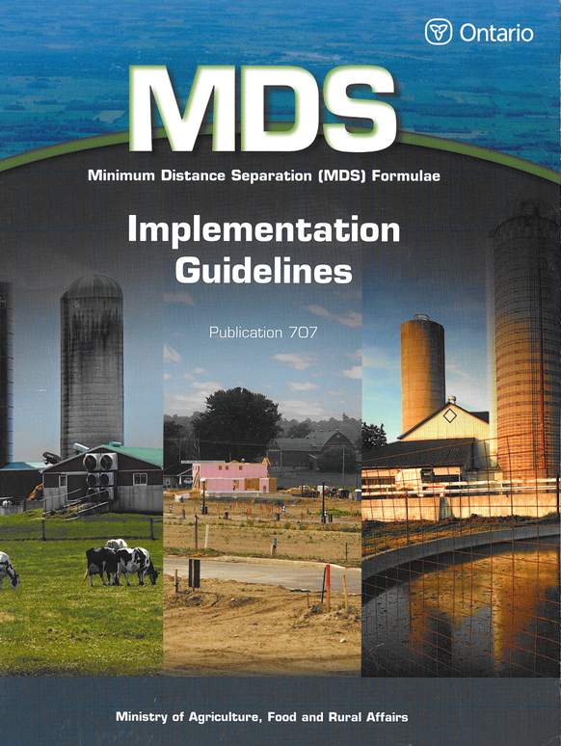

*\** *Refer to document for compliance requirements*: Ministry of Agriculture, Food and Rural Affairs*.* (2006). *Minimum Distance Separation (MDS) Formulae, Implementation Guidelines.* Toronto: Queen’s Printer for Ontario.

# SCHEDULE A